A Characterization of the Australian Financial Assistance Grants System

2025-07-23

Table of contents

# Preface

This is a Quarto book.

To learn more about Quarto books visit <https://quarto.org/docs/books>.

# 1. Introduction

This is a book created from markdown and executable code.

See Knuth (1984) for additional discussion of literate programming.

# 2. Historical Context

# 3. New South Wales Methodology

This is the content for # New South Wales Methodology.

# 4. Victoria Methodology

This is the content for # Victoria Methodology.

# 5. Queensland Methodology

This is the content for # Queensland Methodology.

# 6. South Australia Methodology

This is the content for # South Australia Methodology.

# 7. Western Australia Methodology

This is the content for # Western Australia Methodology.

# 8. Tasmania Methodology

This is the content for # Tasmania Methodology.

# 9. Northern Territory Methodology

This is the content for # Northern Territory Methodology.

# 10. A note on the Australian Classification of Local Government

| **Step 1** | **Step 2** | **Step 3** |  | **Category** | **Alpha** |
| --- | --- | --- | --- | --- | --- |
| **URBAN (U)** |  |  |  |  |  |
|  | Capital City (CC) | Not applicable |  | 1 | UCC |
| **Pop. > 20,000** | Metropolitan Developed (D) - Part of an urban centre > 1,000,000 and pop. density > 600/sq km. | Small (S) | up to 30,000 | 2 | UDS |
|  |  | Medium (M) | 30,001-70,000 | 3 | UDM |
|  |  | Large (L) | 70,001-120,000 | 4 | UDL |
|  |  | Very large (VL) | > 120,000 | 5 | UDV |
| **Pop. Density > 30 persons per sq km** | Regional Town/City (R) - Part of an urban centre with population <1,000,000 and predominantly urban in nature | Small | up to 30,000 | 6 | URS |
|  |  | Medium | 30,001-70,000 | 7 | URM |
|  |  | Large | 70,001-120,000 | 8 | URL |
|  |  | Very large | >120,001 | 9 | URV |
| **>90% of LGA population is urban** | Fringe (F) - A developing LGA on the margin of a developed or regional urban centre. | Small | up to 30,000 | 10 | UFS |
|  |  | Medium | 30,001-70,000 | 11 | UFM |
|  |  | Large | 70,001-120,000 | 12 | UFL |
|  |  | Very large | >120,001 | 13 | UFV |
| **RURAL (R)** |  |  |  |  |  |
|  | Significant Growth (SG) - Average annual Population growth > 3%, population > 5,000 and not remote. | Not applicable |  | 14 | RSG |
|  | Agricultural (A) | Small | Up to 2,000 | 15 | RAS |
|  |  | Medium | 2,001-5,000 | 16 | RAM |
|  |  | Large | 5,001,-10,000 | 17 | RAL |
|  |  | Very large | 10,001 to 20,000 | 18 | RAV |
|  | Remote (T) - Situated in a remote locality. | Extra small | Up to 400 | 19 | RTX |
|  |  | Small | 401-1,000 | 20 | RTS |
|  |  | Medium | 1,001–3,000 | 21 | RTM |
|  |  | Large | 3,001 to 20,000 | 22 | RTL |

# 11. Discussed Issues

This is the content for # Discussed Issues.

# 12. Methodology: Grants Simulation

This notebook simulates the allocation of Financial Assistance Grants to Australian states and territories.

For each region, the specific methodology is explained in markdown cells following the code implementation.

At a high level, we use whatever information we have out there to construct a profile of need in 2024-25 for each council.

Then, for the subsequent years, we sample movement of that need from a normal distribution centred at 1, with a standard deviation of 0.1 - essentially, a council can be expected to experience a change between -20% and +20% about 95% of the time.

A reduction in the gap implies improved financial sustainability.

For each year that follows, fund allocation methodology is implemented for each state based on that state’s Grant Commission’s methodology.

This process is repeated 1000 times for each council to capture as much of the variability as possible.

## 12.1 Controls and constants

We first define two per_capita_minimum parameters for the simulation - one as the scenario under study and the other as a benchmark.

Then, we grab projected values for FA Grants and the Estimated Resident Population in June from the budget papers. The June ERP was chosen as a metric over methodology specific ERP values (some states use population data from up to 5 years before the allocation year in their allocation methodology) simply to standardize the variable and make the model easy to maintain.

## 12.2 States with data constraints

Queensland and New South Wales do not release their “Funding Gap” variables. Hence, an analogue is reverse engineered from the gap between grant entitlement and minimum grant. Adjustments and normalizations applied to this should, in principle, give fairly robust numbers, especially at the high level.

Given the lack of published data, a synthetic metric of need - the scaled gap, for a council i in a state S is defined as

$$Gap_{i}=\frac{General Purpose Grant_{i}−Minimum Allocation_{i,per capita basis}}{Total General Purpose Grant_{S}−Total Per Capita Allocation_{S}}$$

### 12.2.1 New South Wales

No explicit cap or collar has been defined.

### 12.2.2 Queensland

There’s no cap/collar and minimum grant eligibility is based on population > 80,000.

## 12.3 States with workable data

For these states, a simple algorithm for allocation is defined.

1. A raw allocation based on funding gap is made, respectful of minimum grant requirements.
2. This raw allocation is compared to funding from the previous year to determine the magnitude of movement.
3. An iterative process is used to reallocate funds away from “overfunded” (as defined by movement) councils.
4. The redistribution loop is run either until
   * all councils see movement within the defined caps and collars
   * there’s no change in the distribution over iterations.

For Victoria, South Australia, and Tasmania a constraint has been placed on the number of iterations run. For the first 100 iterations, both upper and lower limits are enforced. After that, only the lower limits are explicitly enforced.

### 12.3.1 Victoria

Victorial uses a cap/collar of [2%, 10%] for councils.

### 12.3.2 South Australia

South Australia OLG has a cap/collar of [-15%, 30%] for councils.

### 12.3.3 Western Australia

WA State Grants Commission has no ceiling on change, but claims to limit year on year decrease. No explicit floor is given, but the biggest 2023-24 to 2024-25 decrease was about -60%. So, that’s the floor we’ll use.

### 12.3.4 Tasmania

Tasmania State Grants Commission has a cap/collar of [-5%, 10%] for all councils.

### 12.3.5 Northern Territory

Northern Territory has a collar of -5% for all councils.

# 13. A 20% Per Capita Minimum Grant

* The model here applies a hypothetical per capita minimum grant constraint, set at 20%, to ensure that each jurisdiction receives at least this proportion of the funds if they were allocated on a per capita basis.
* The per capita minimum for the benchmark scenario is set to 30%, as is the status quo.

## 13.1 New South Wales

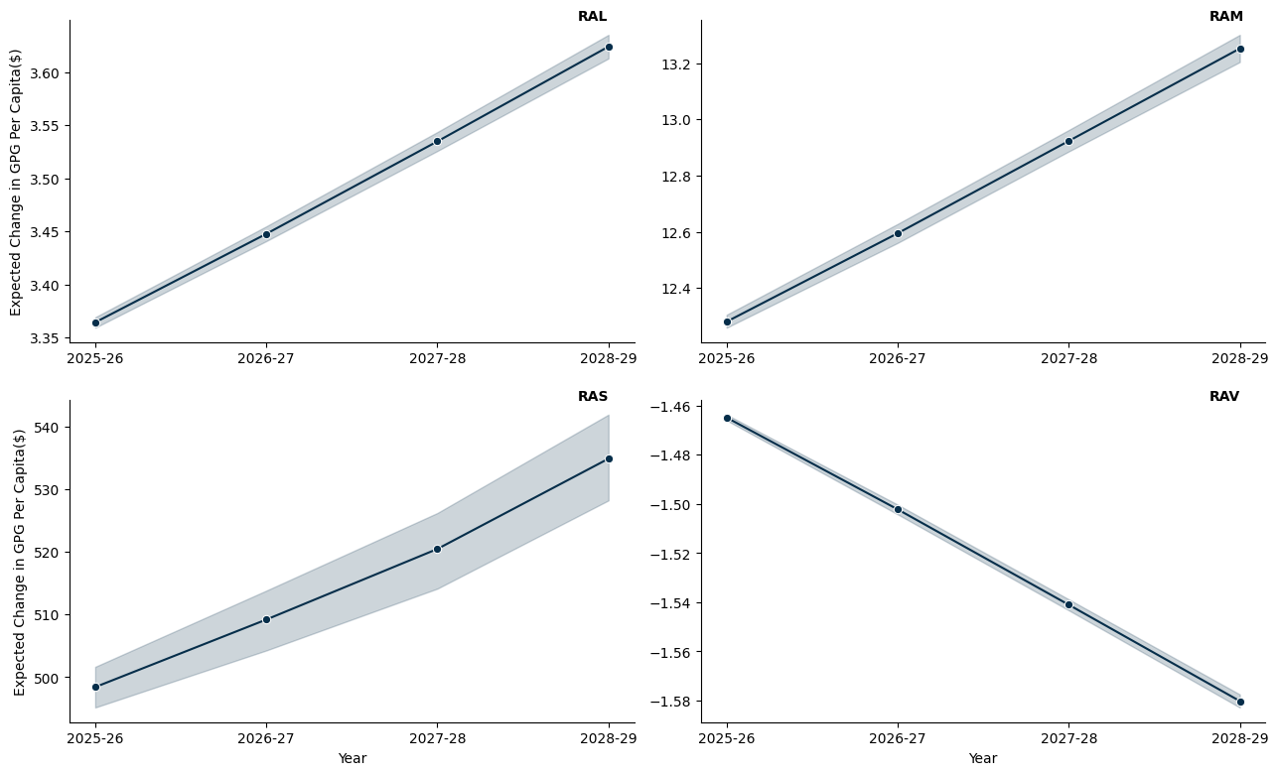

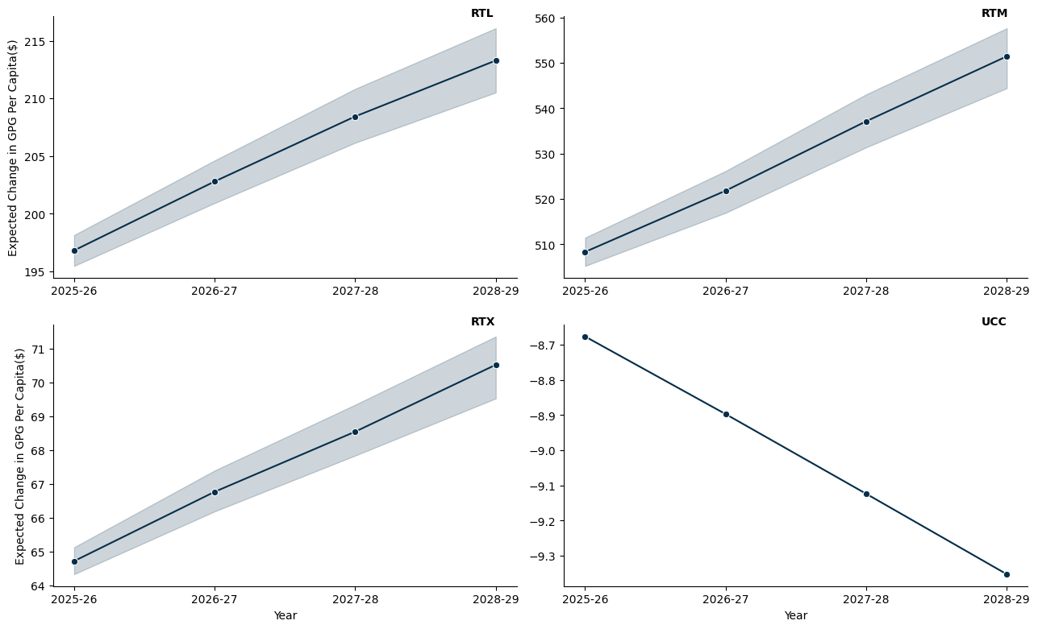

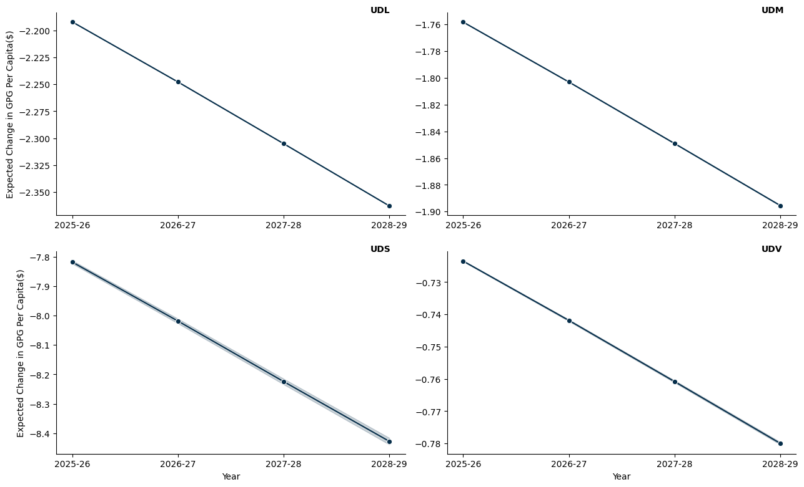

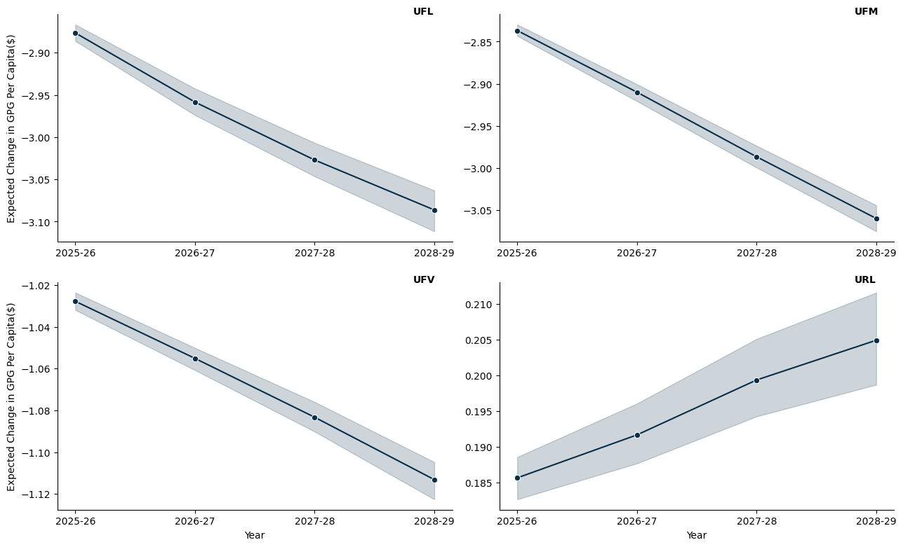

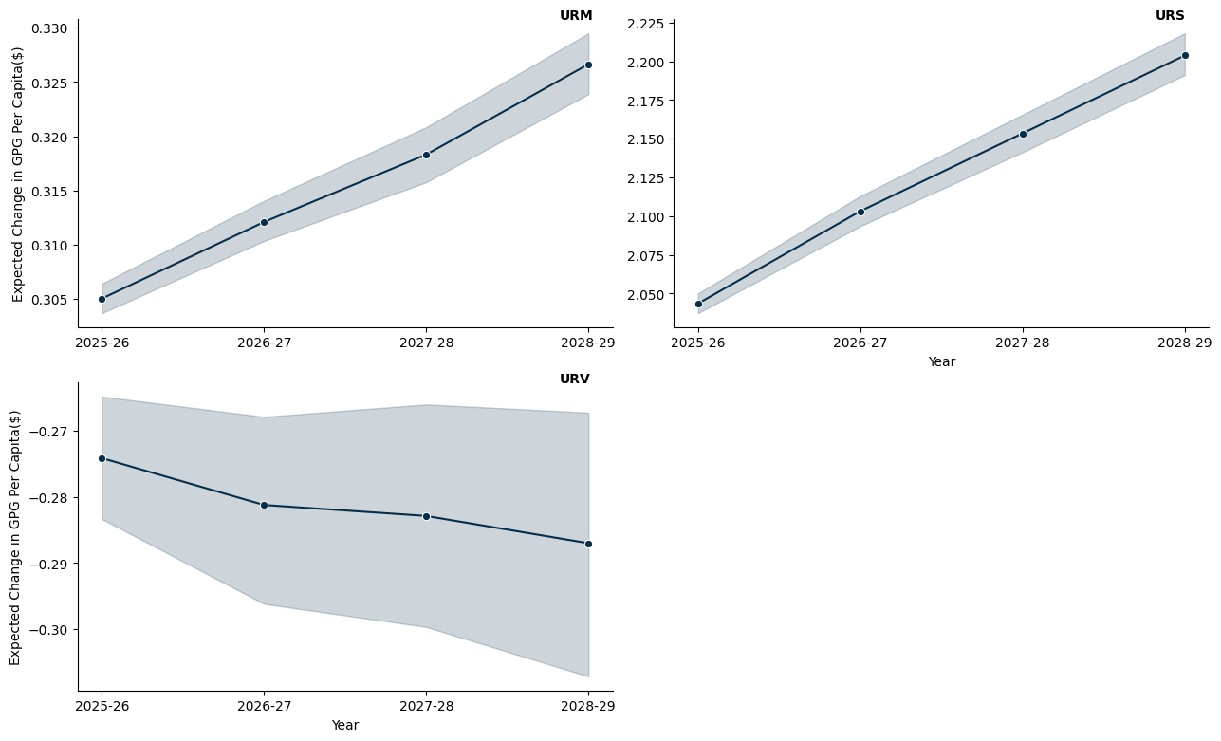

## 13.2 Victoria

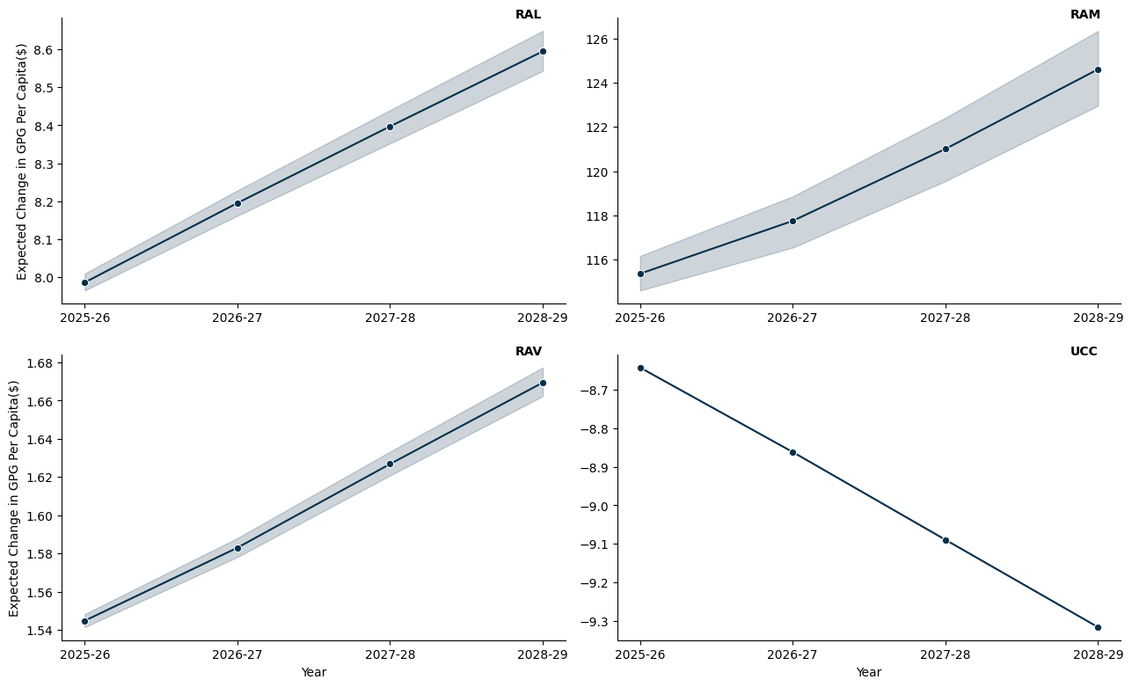

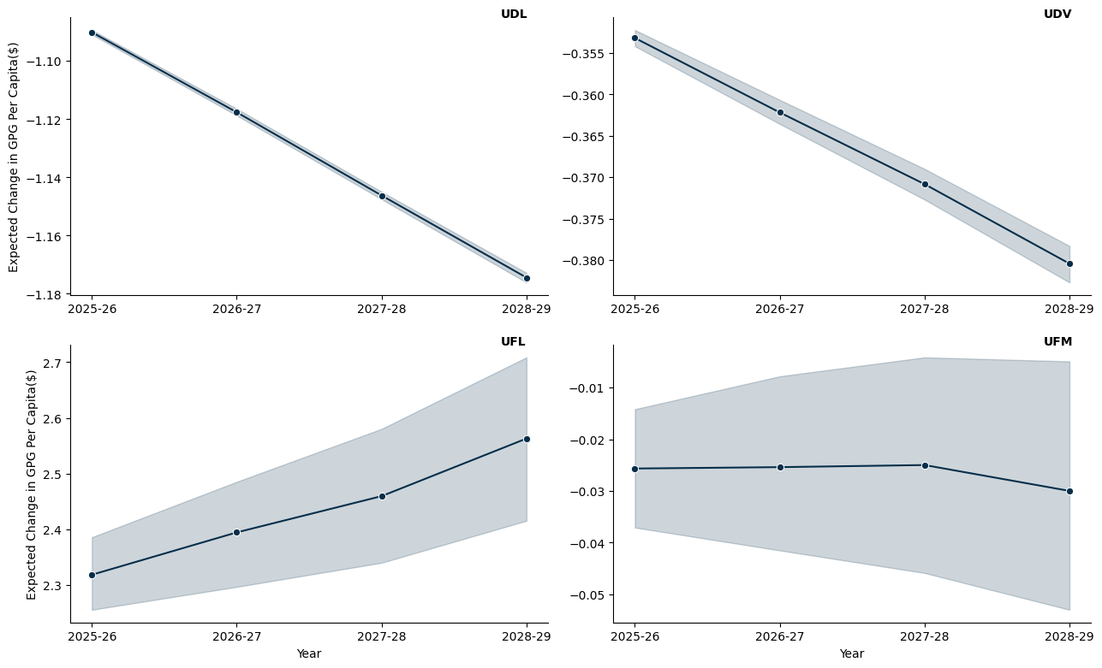

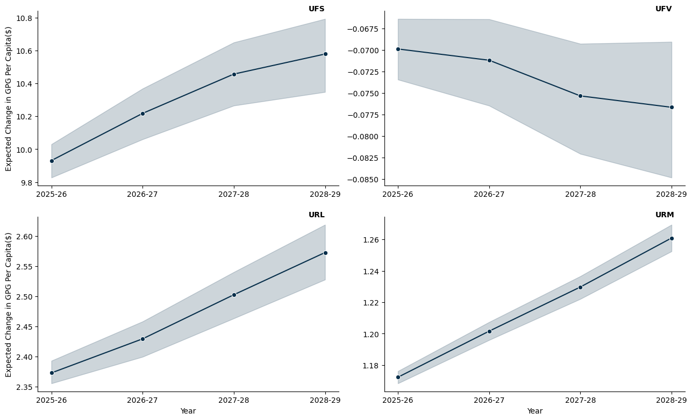

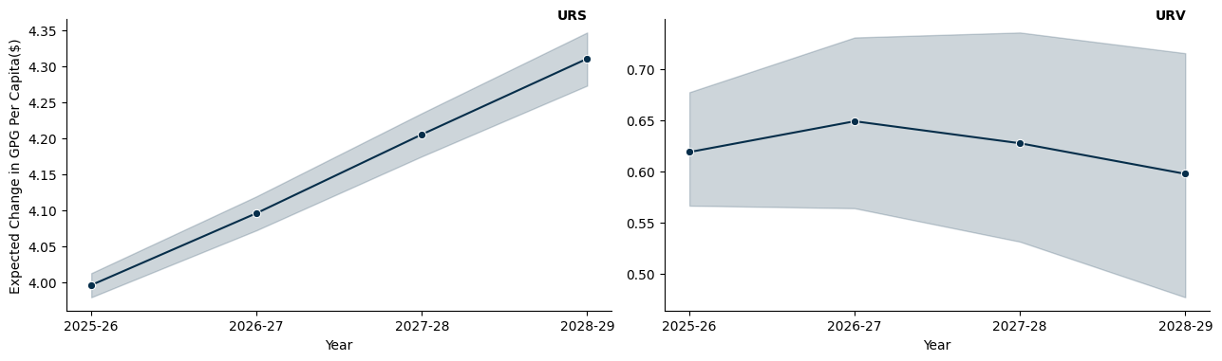

## 13.3 Queensland

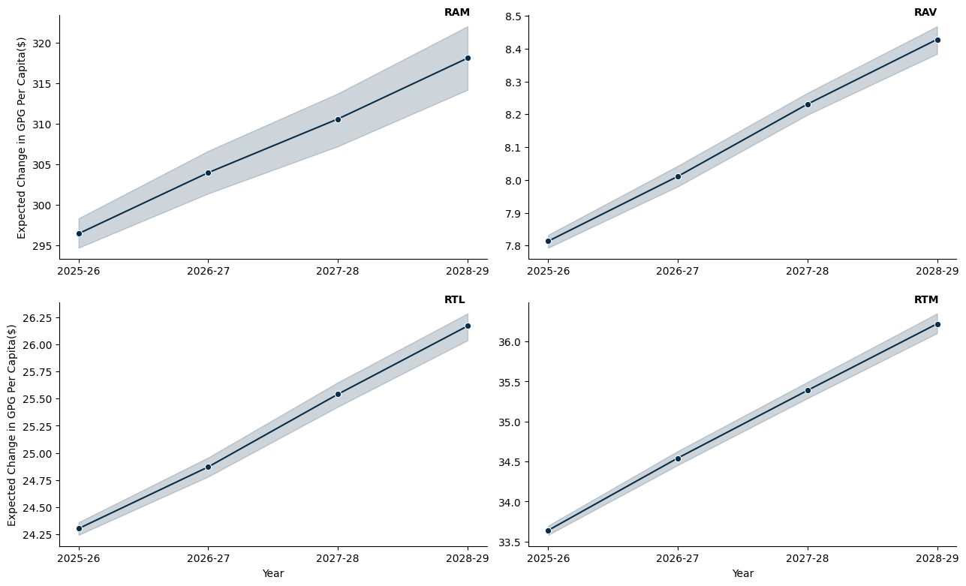

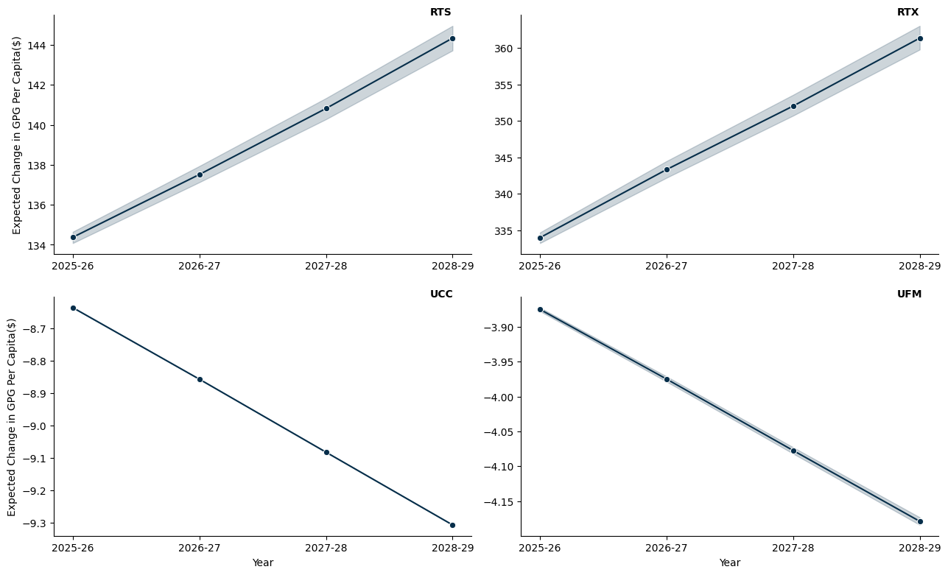

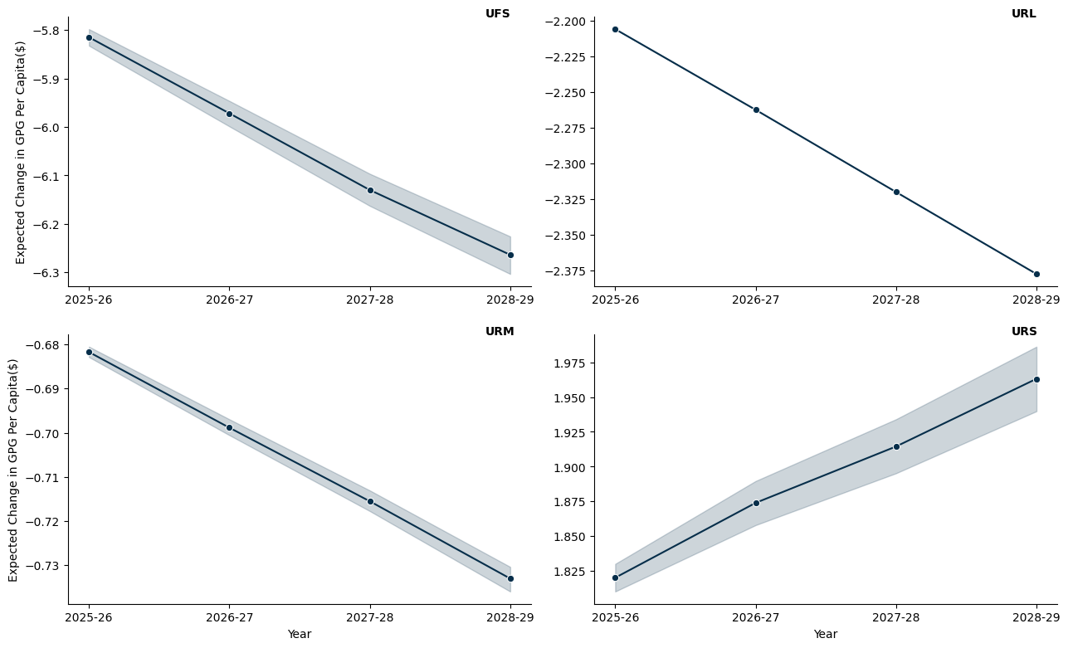

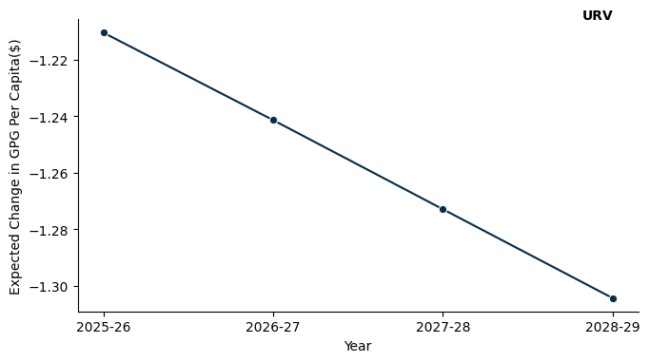

## 13.4 South Austrlalia

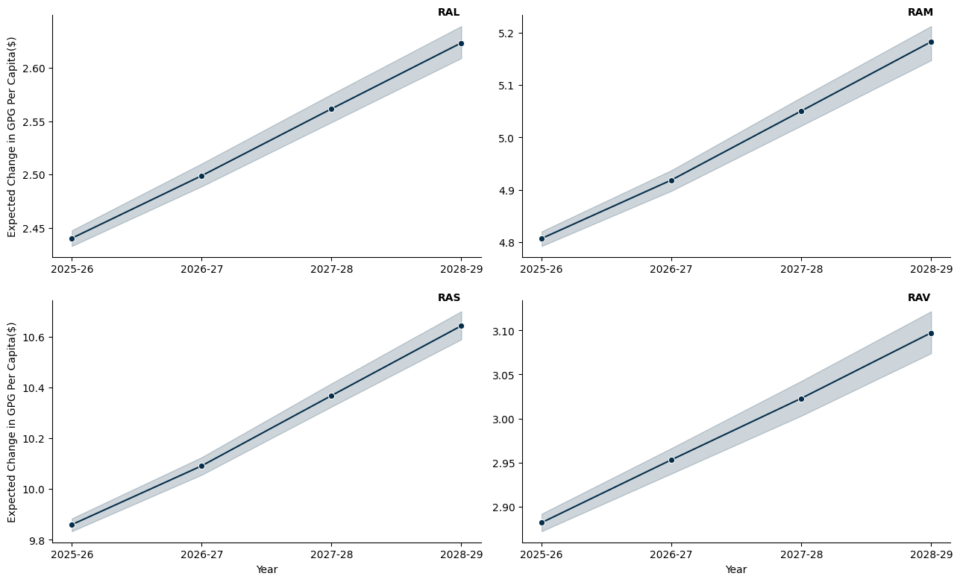

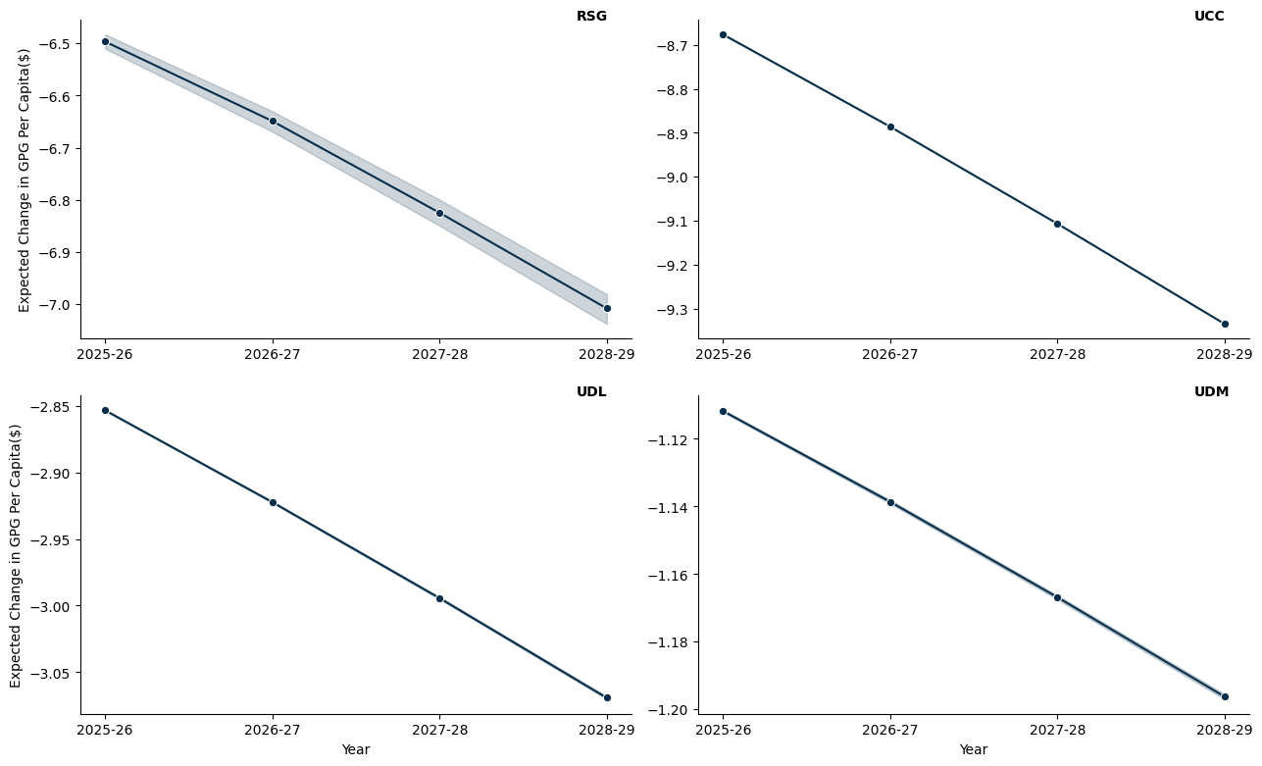

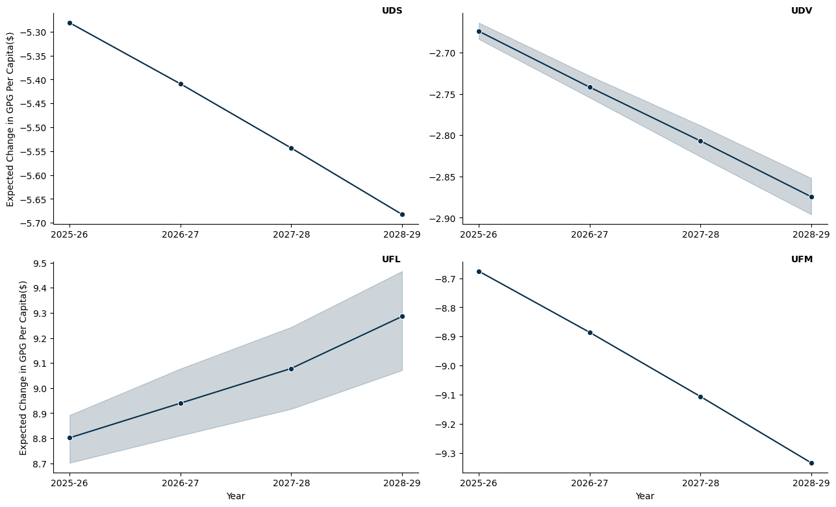

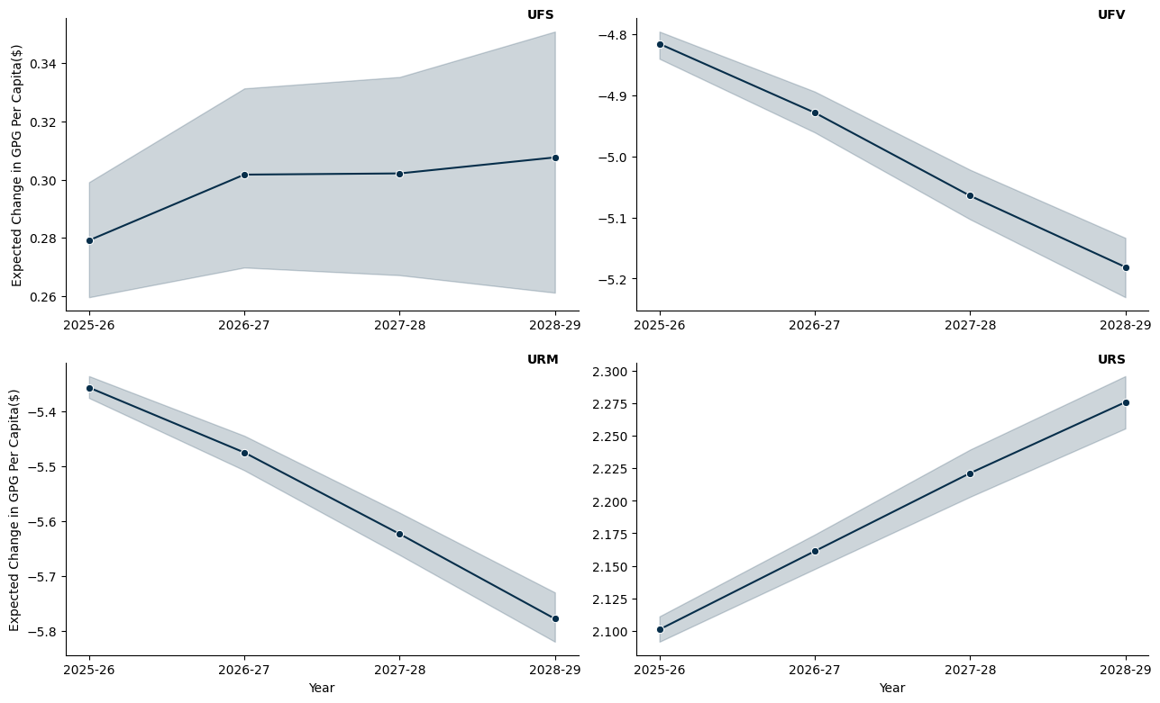

## 13.5 Western Australia

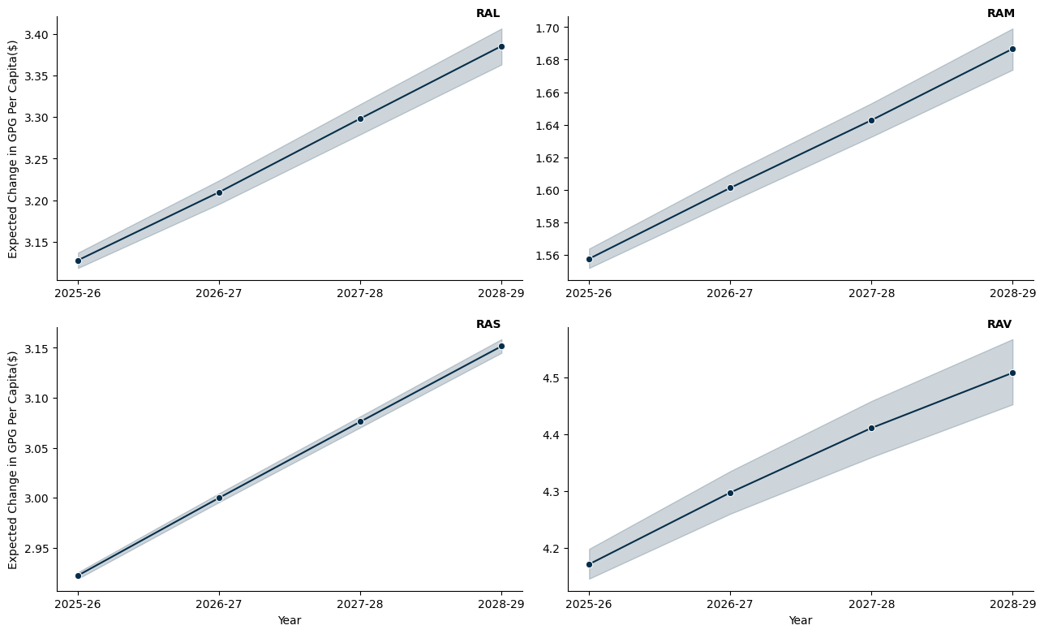

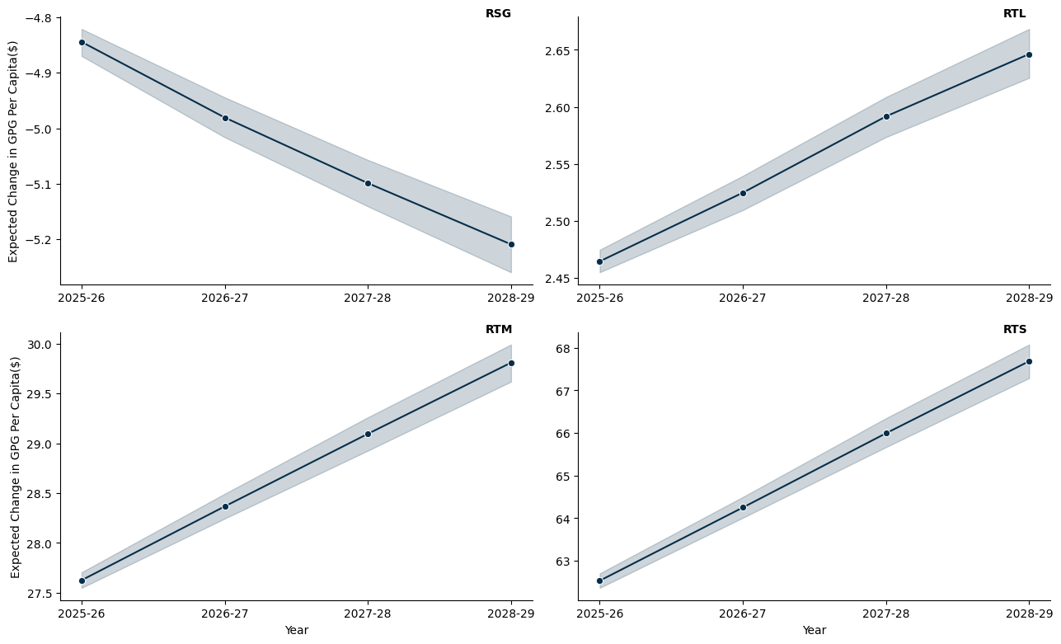

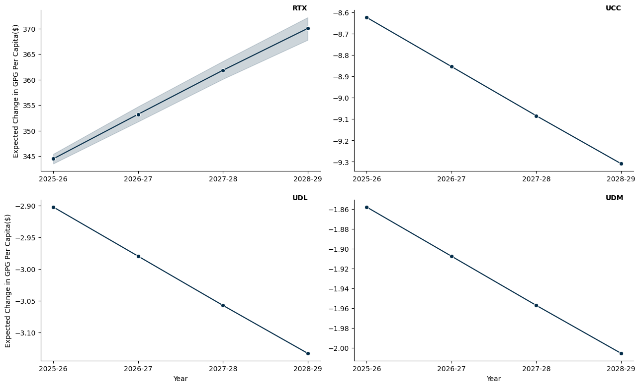

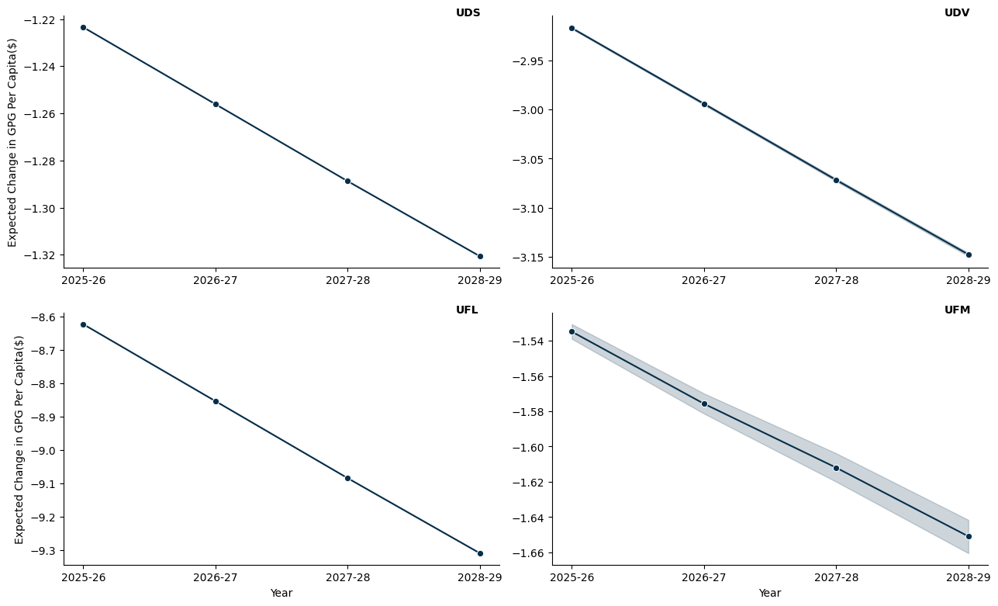

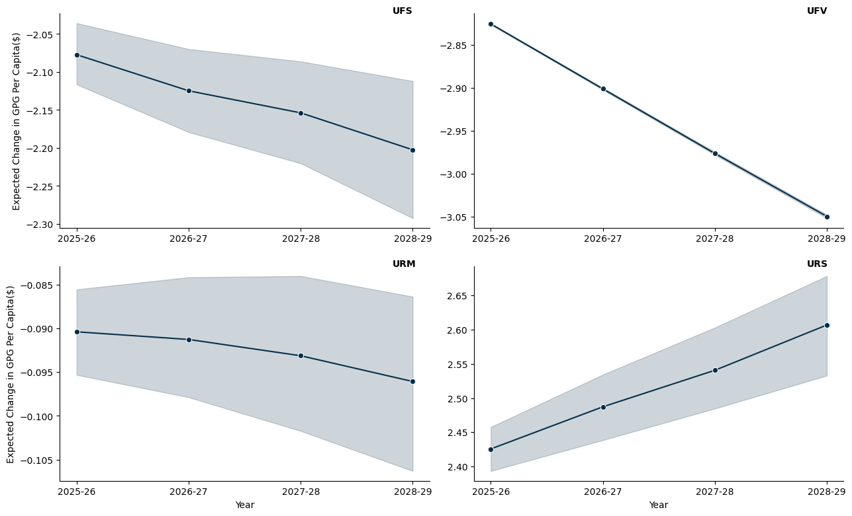

## 13.6 Tasmania

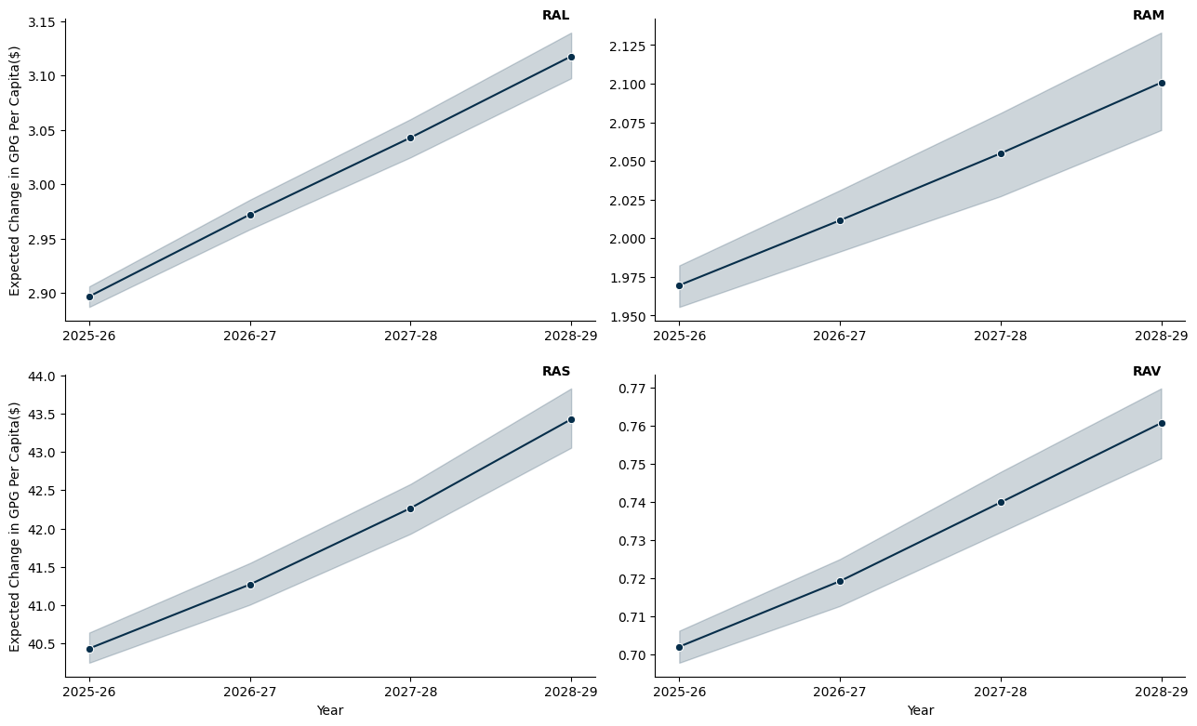

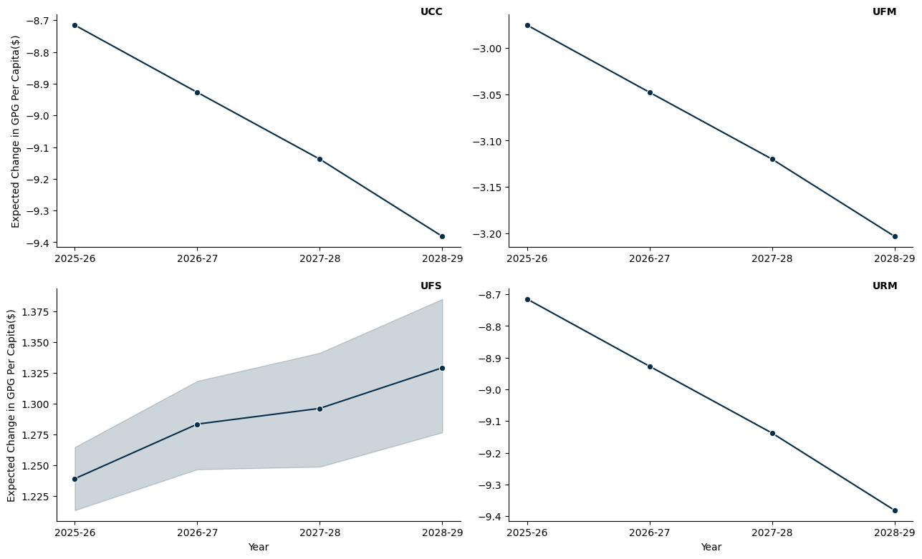

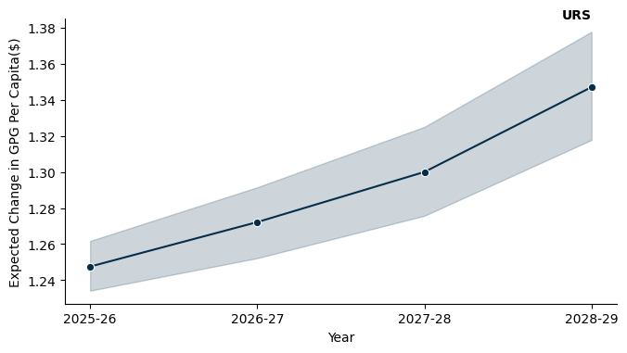

## 13.7 Northern Territory

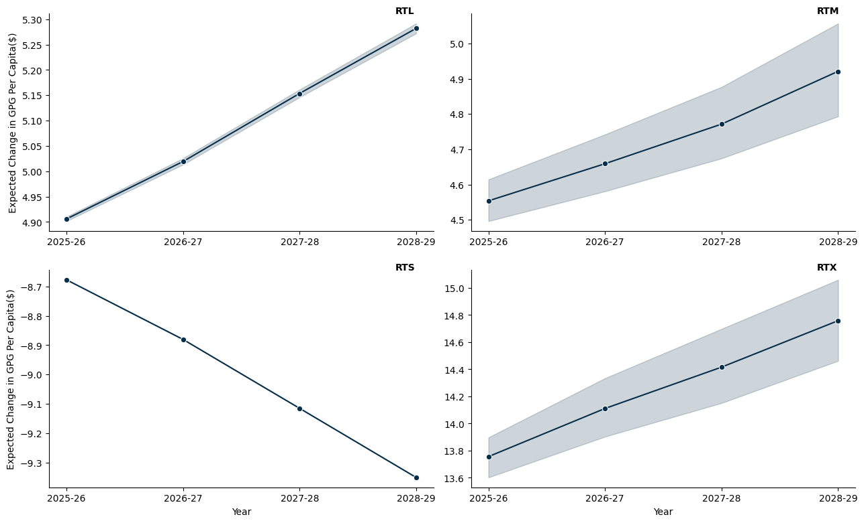

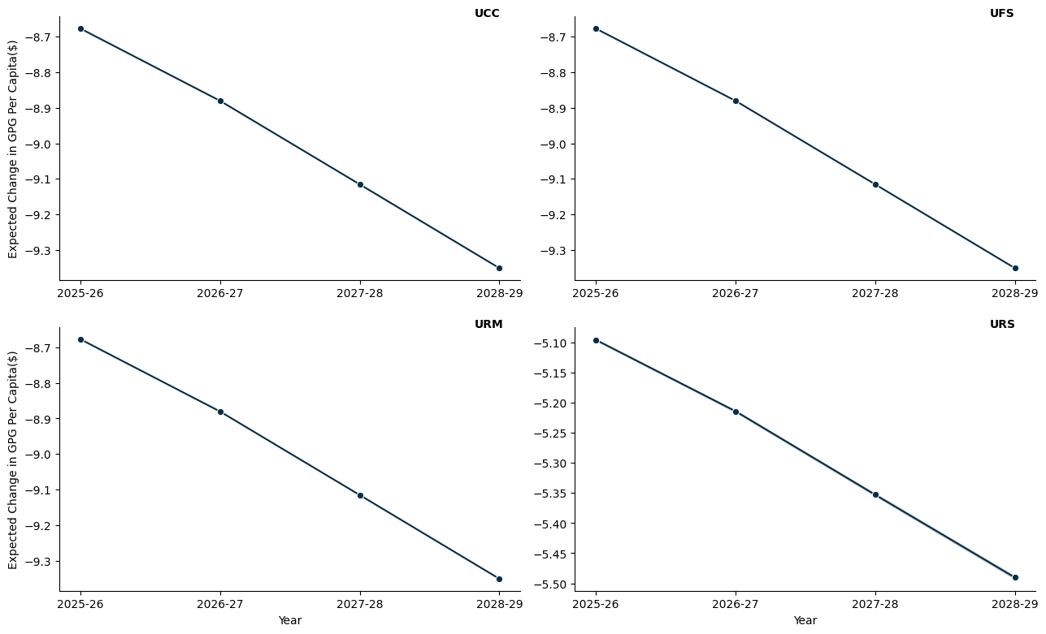

# 14. A 10% Per Capita Minimum Grant

* The model here applies a hypothetical per capita minimum grant constraint, set at 10%, to ensure that each jurisdiction receives at least this proportion of the funds if they were allocated on a per capita basis.
* The per capita minimum for the benchmark scenario is set to 30%, as is the status quo.

## 14.1 New South Wales

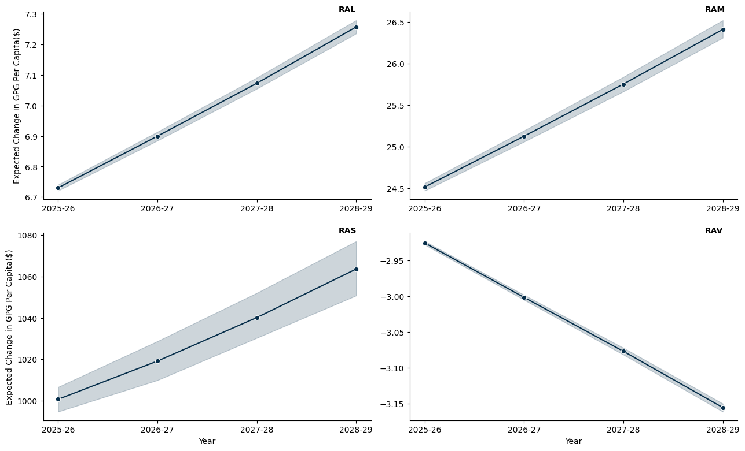

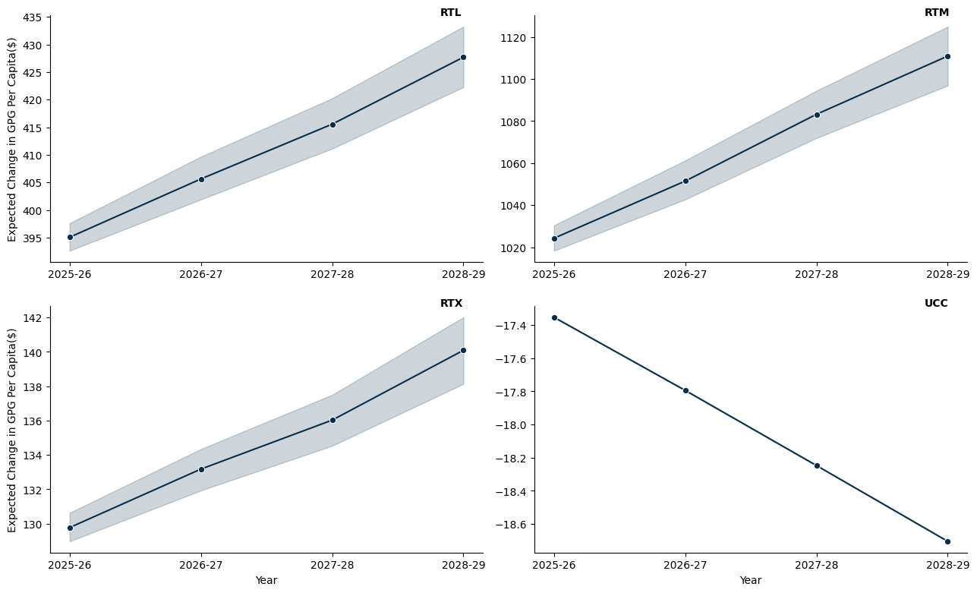

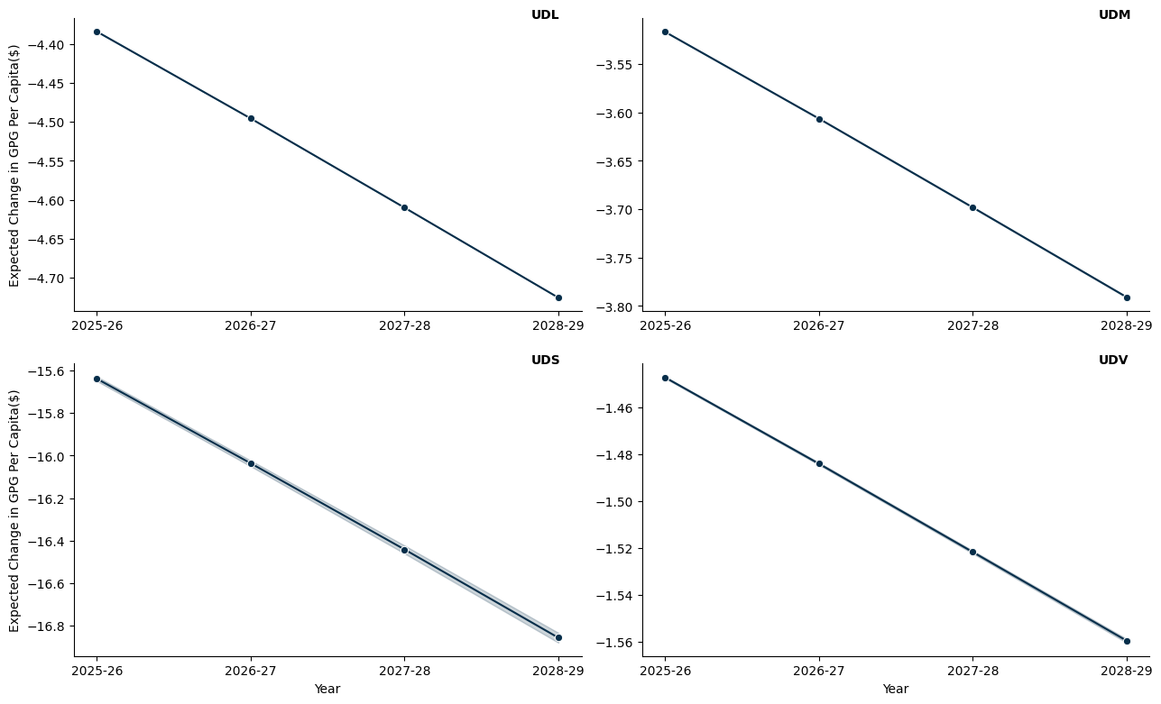

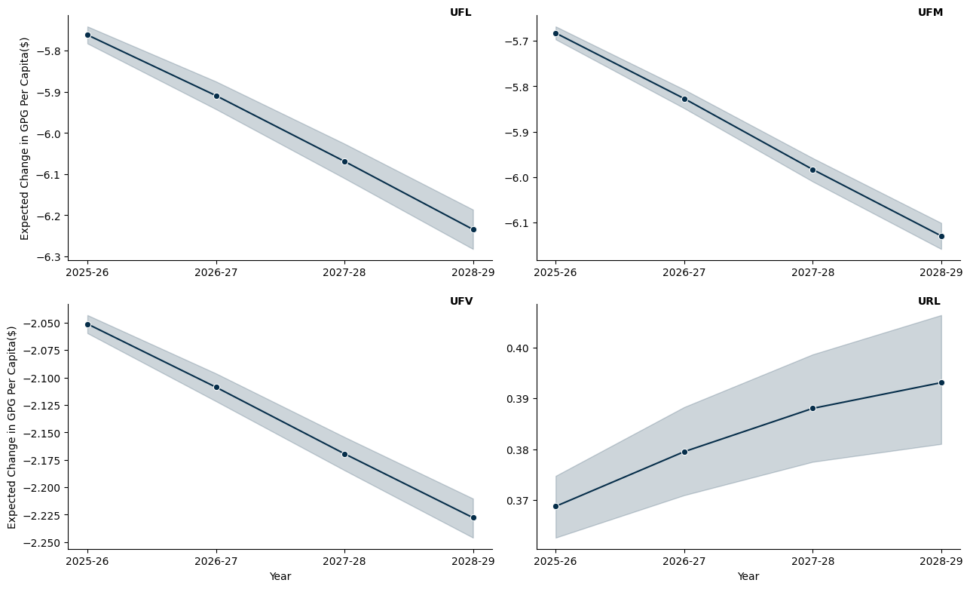

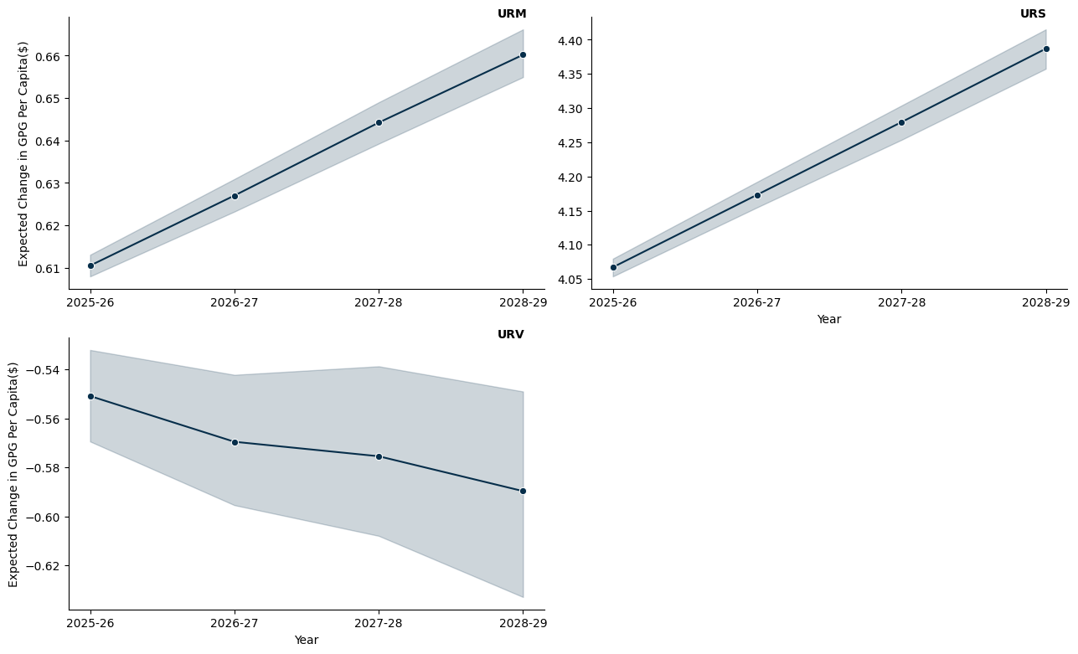

## 14.2 Victoria

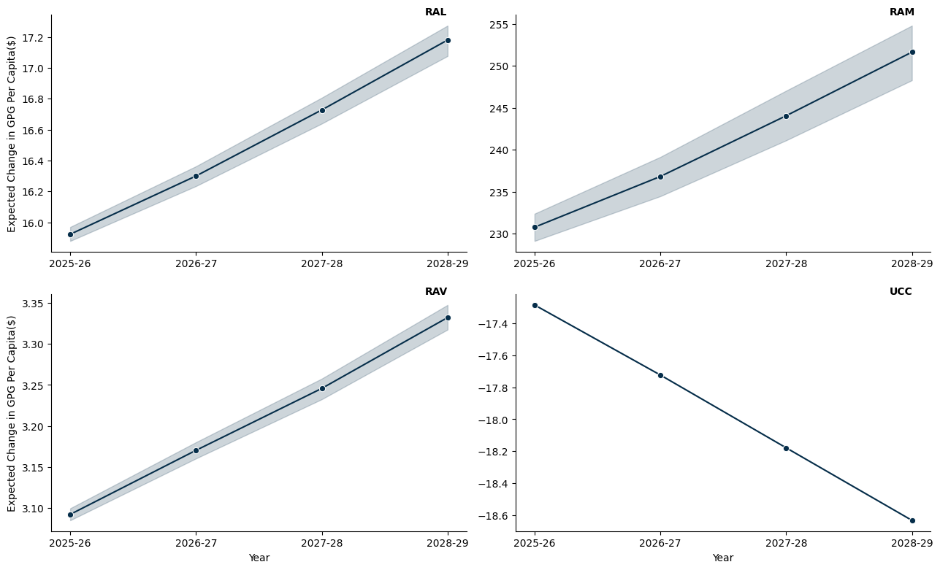

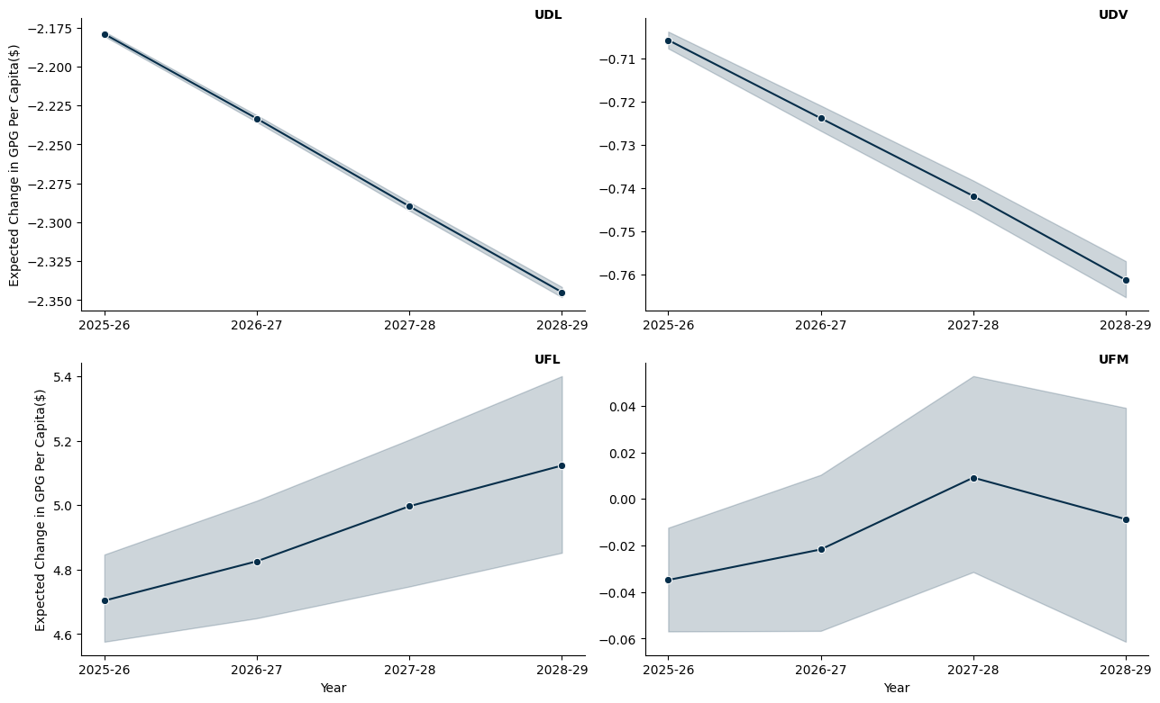

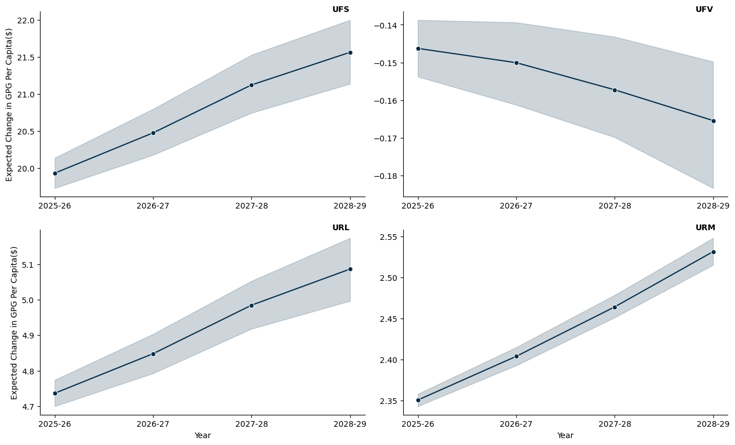

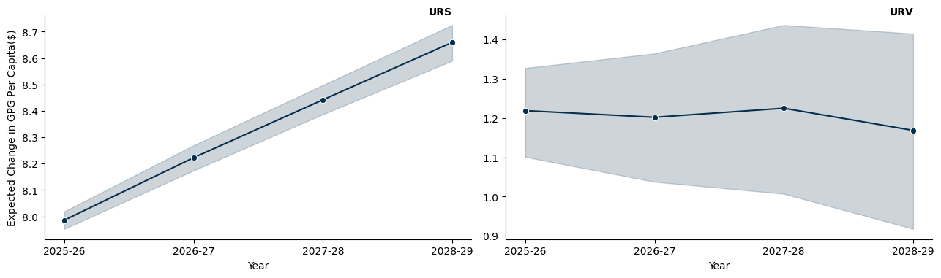

## 14.3 Queensland

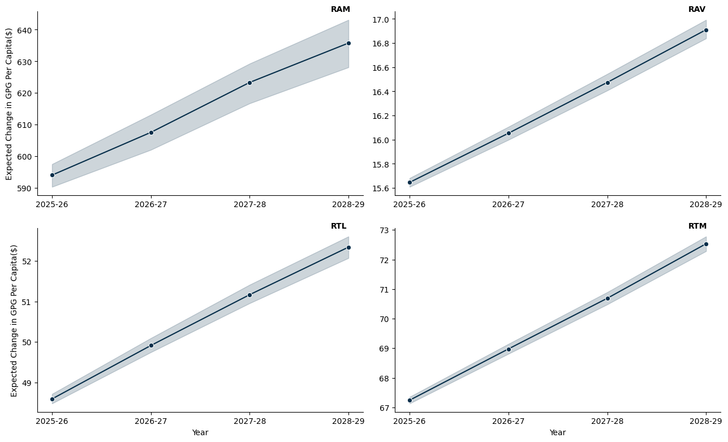

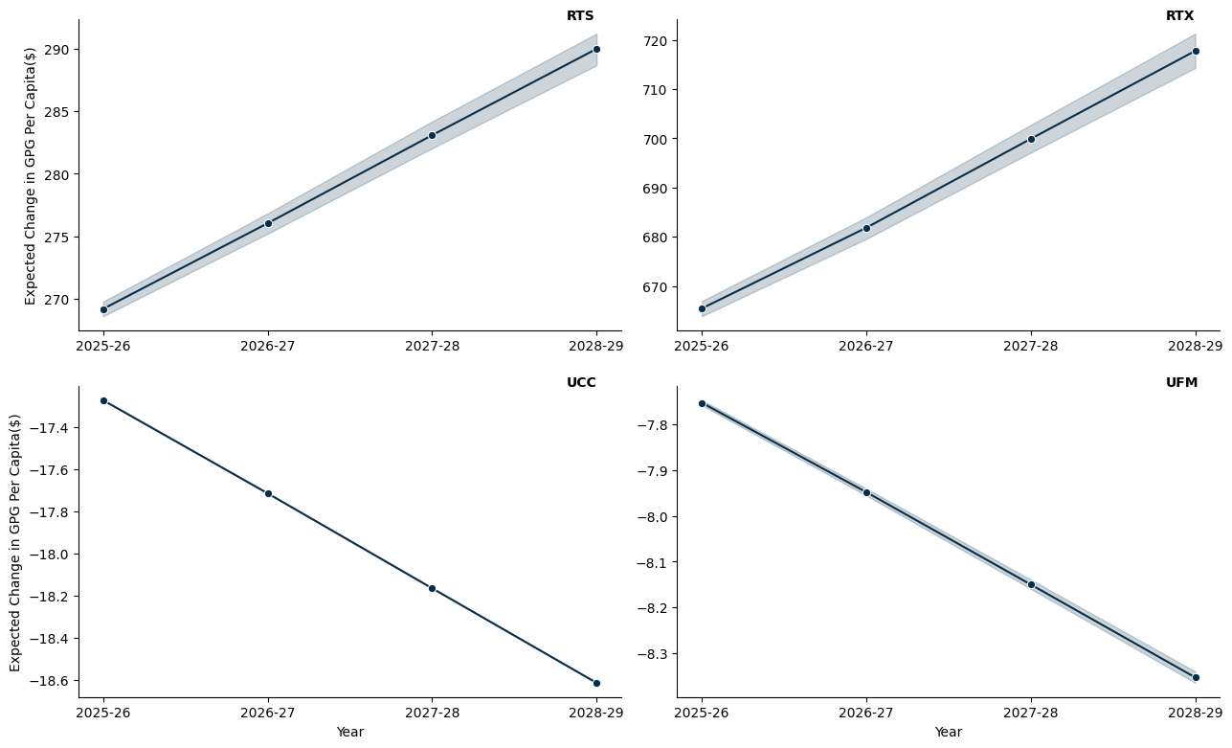

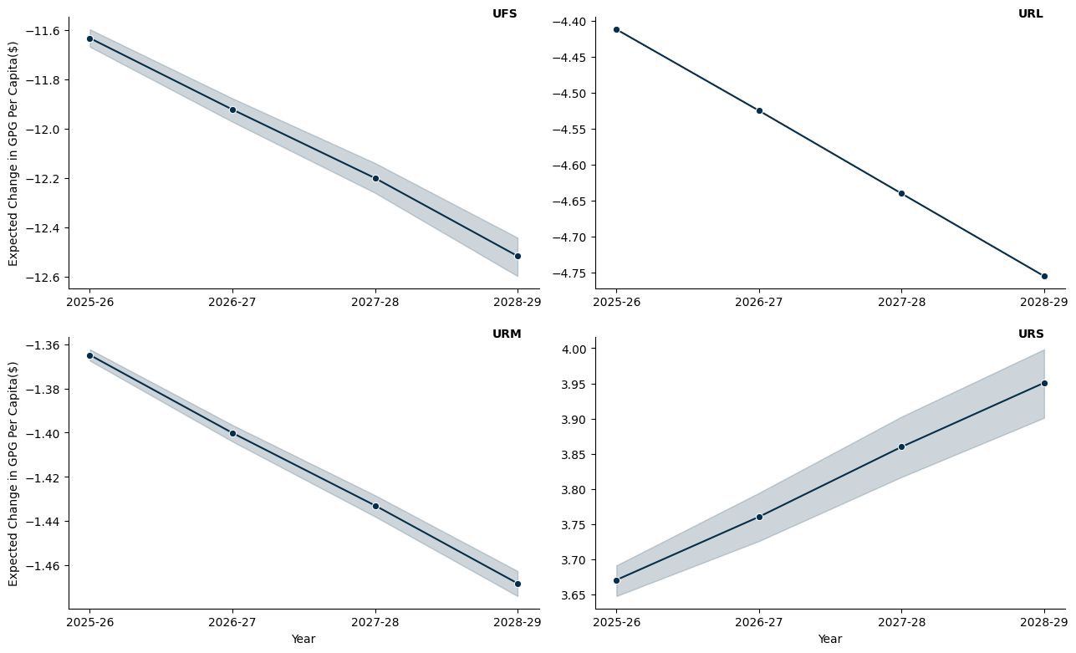

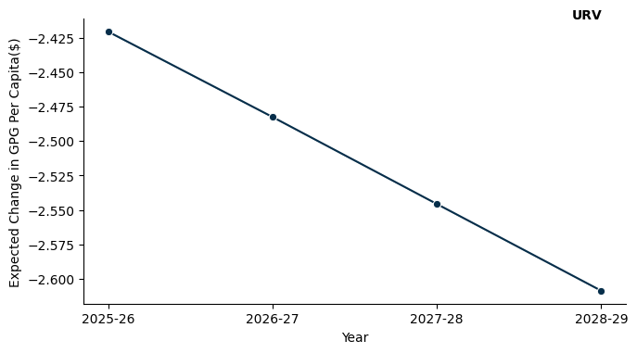

## 14.4 South Austrlalia

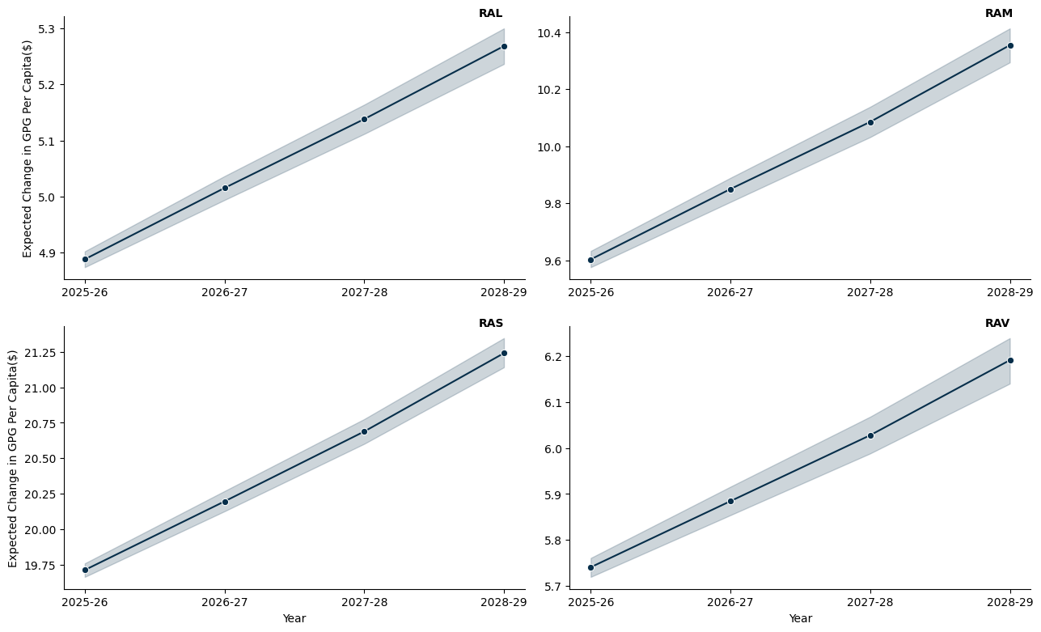

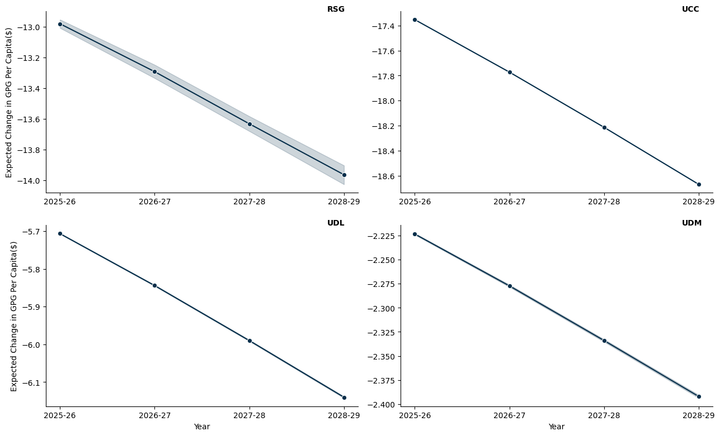

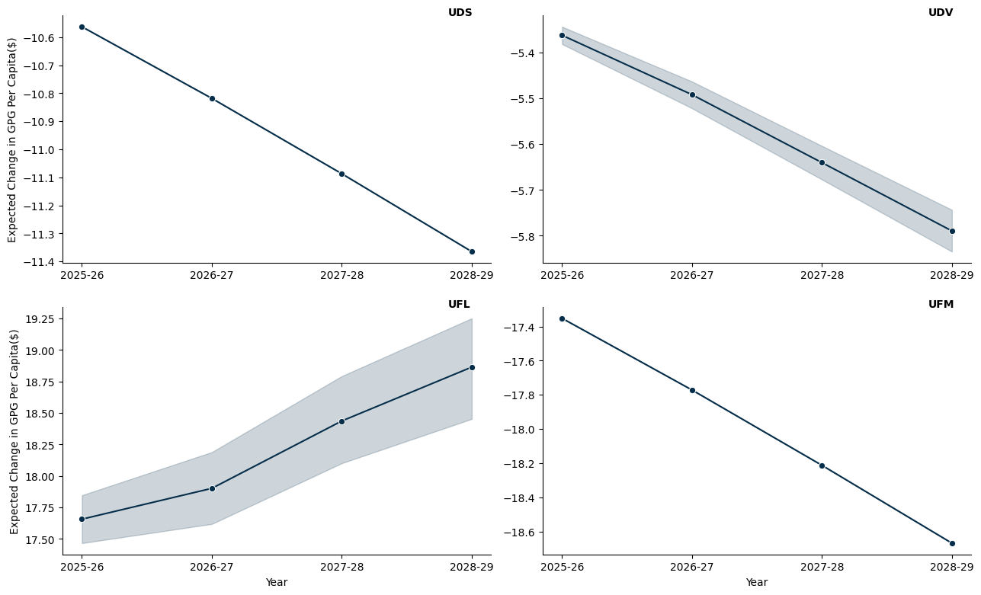

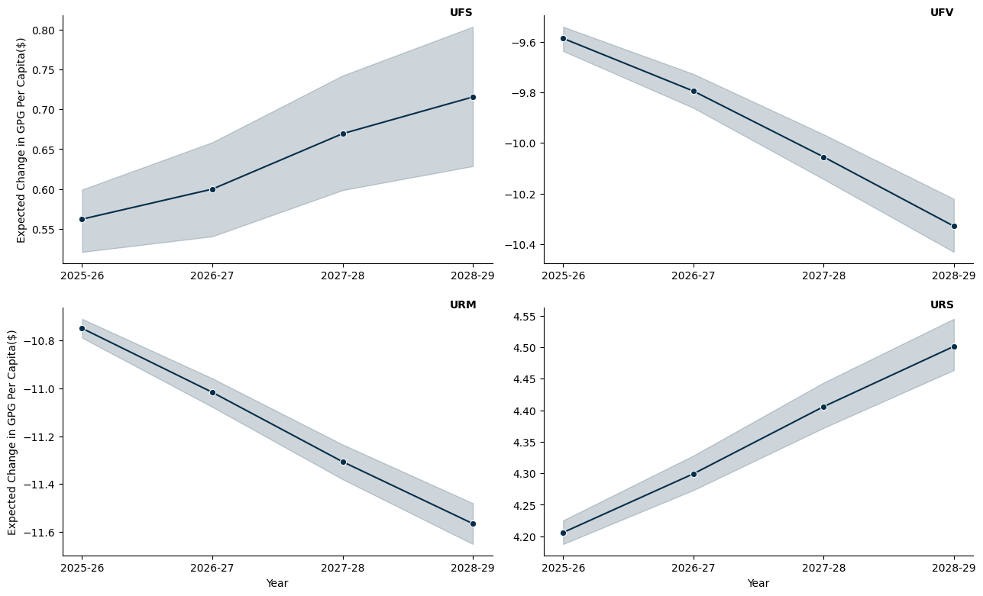

## 14.5 Western Australia

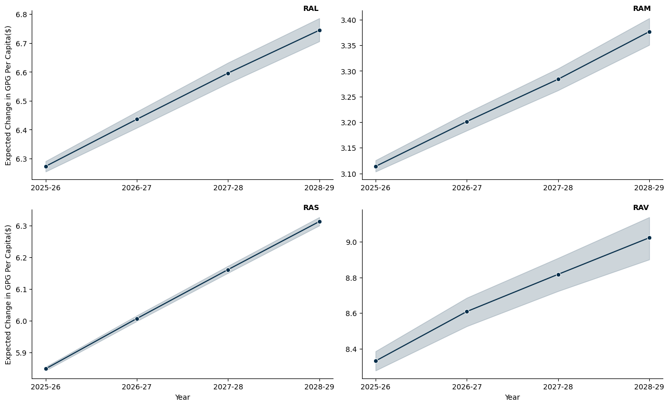

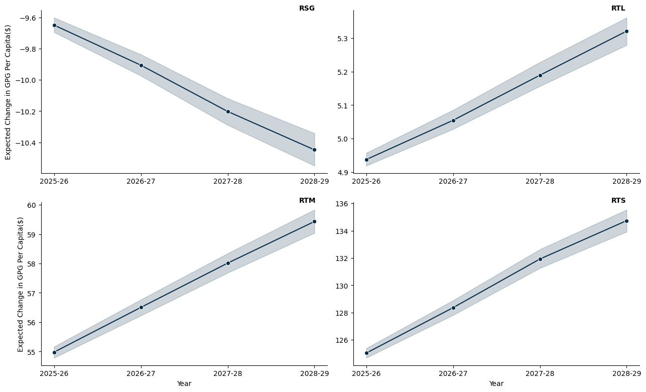

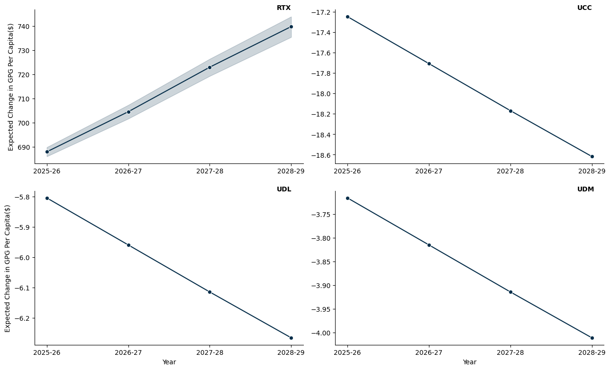

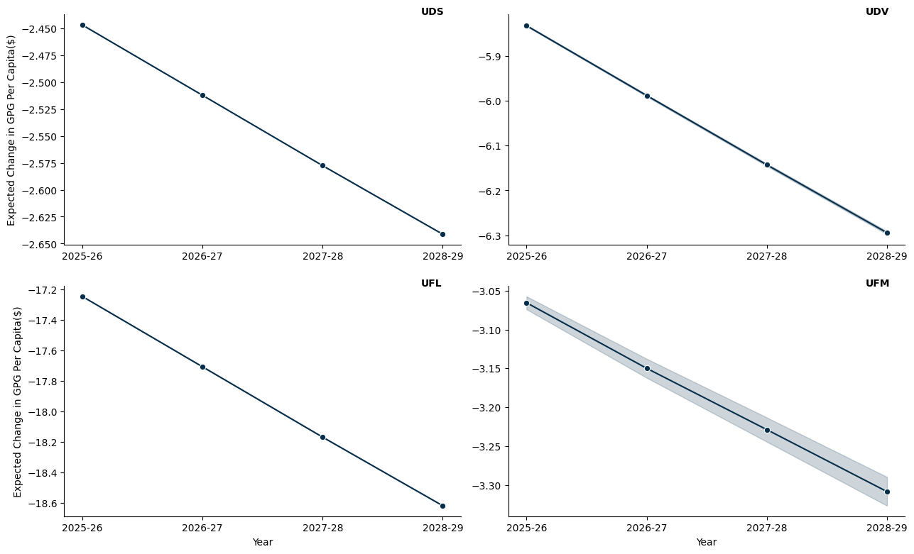

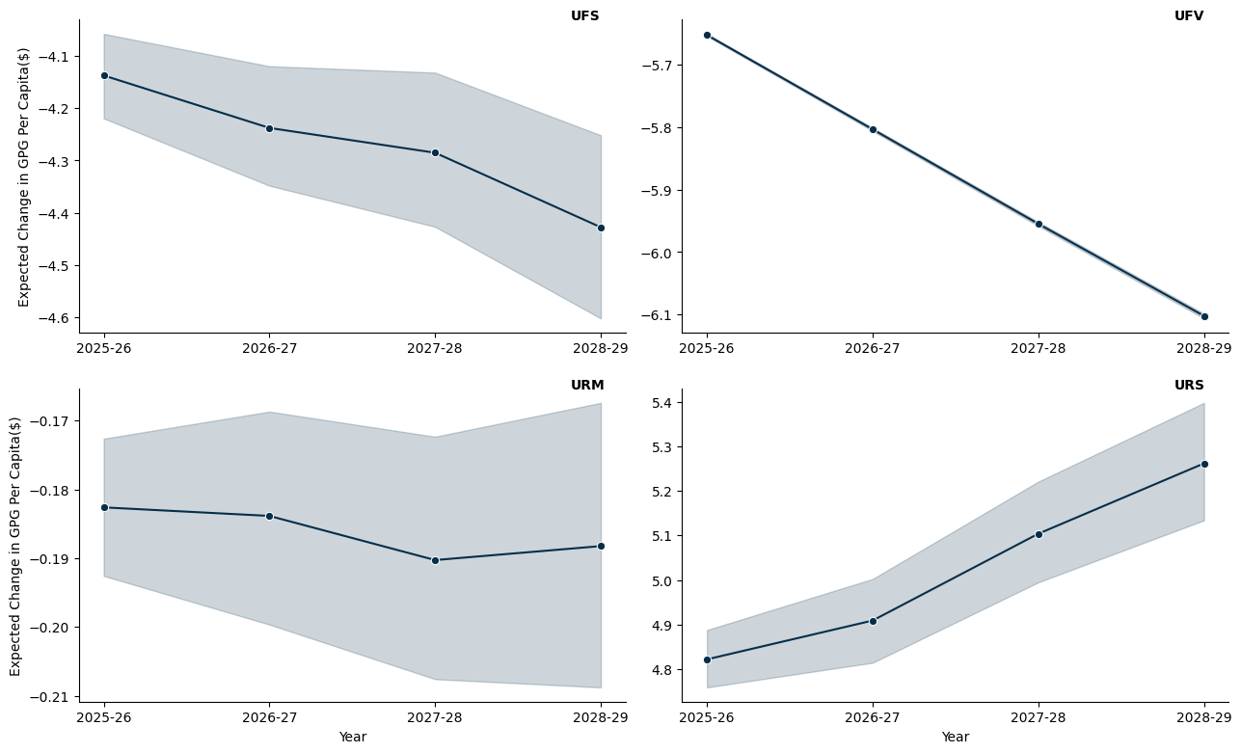

## 14.6 Tasmania

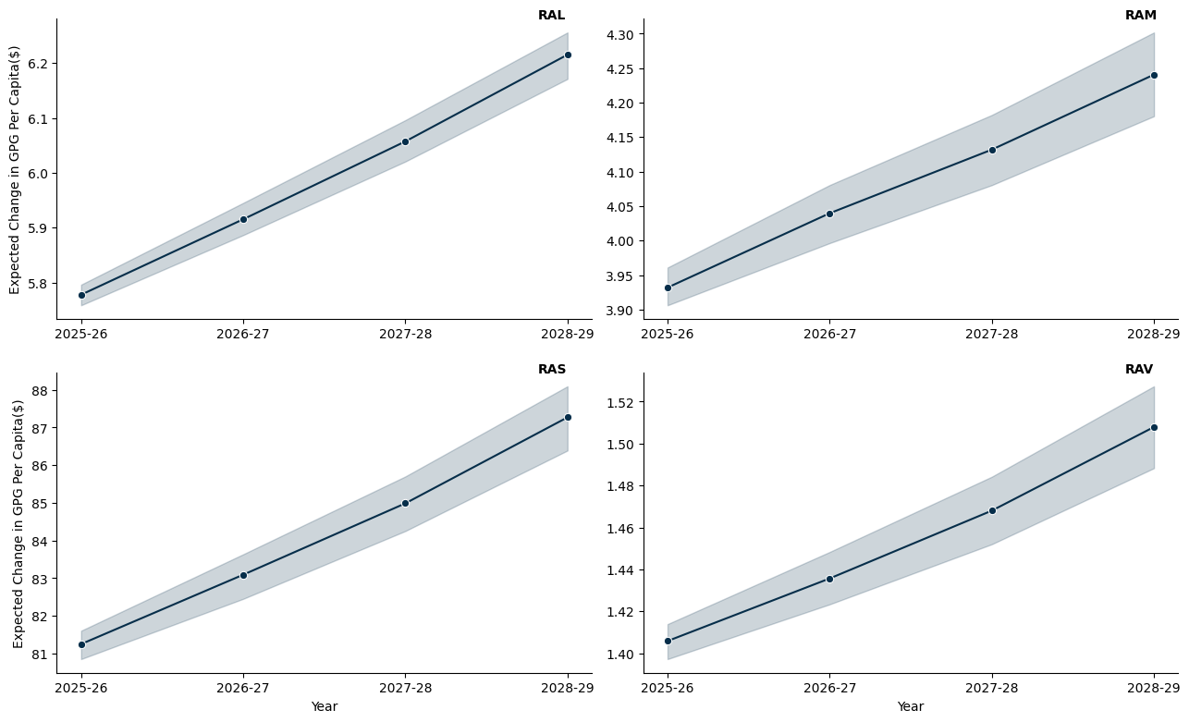

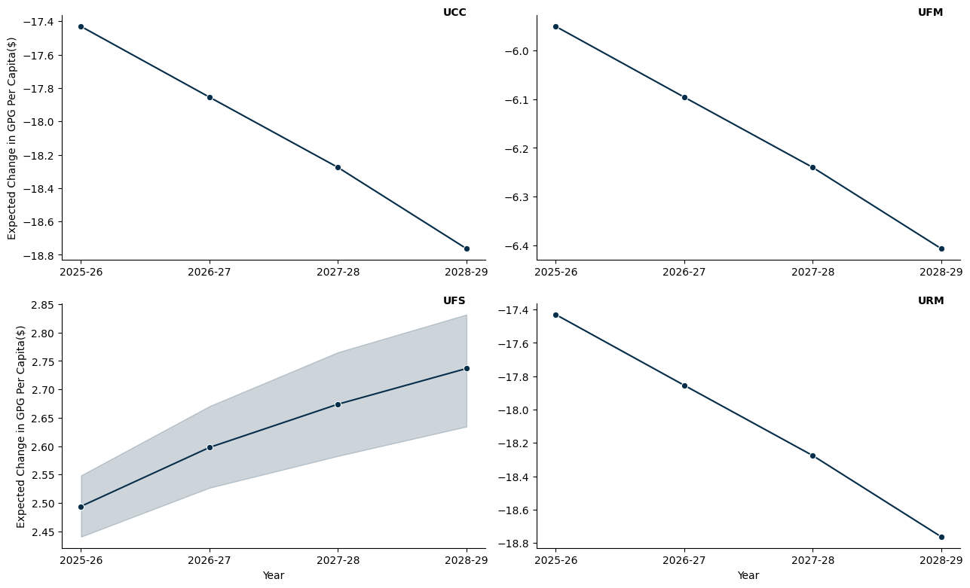

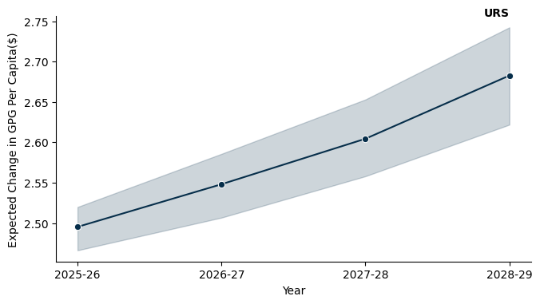

## 14.7 Northern Territory

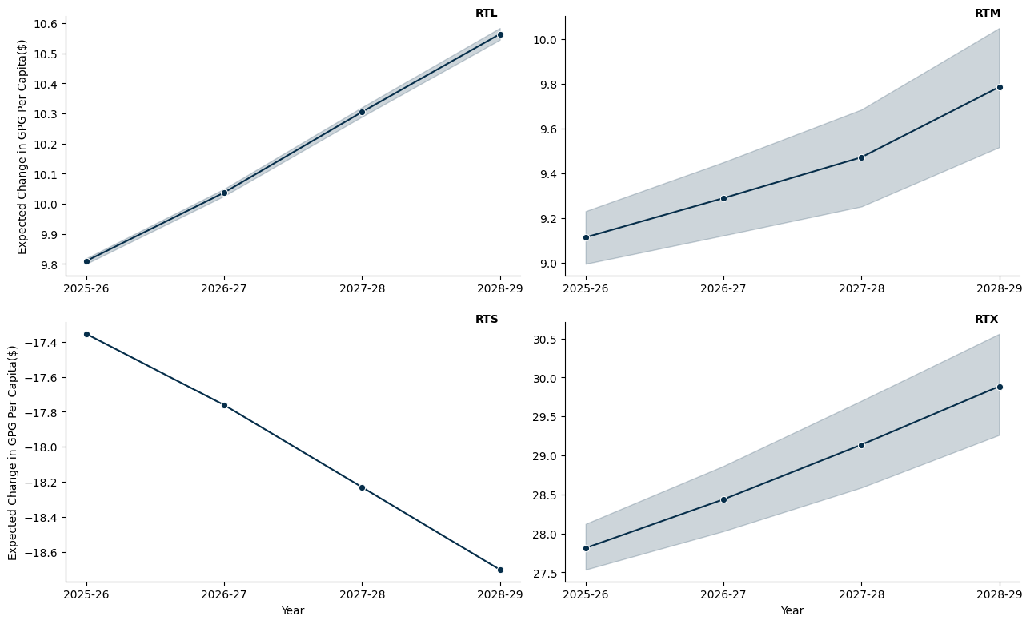

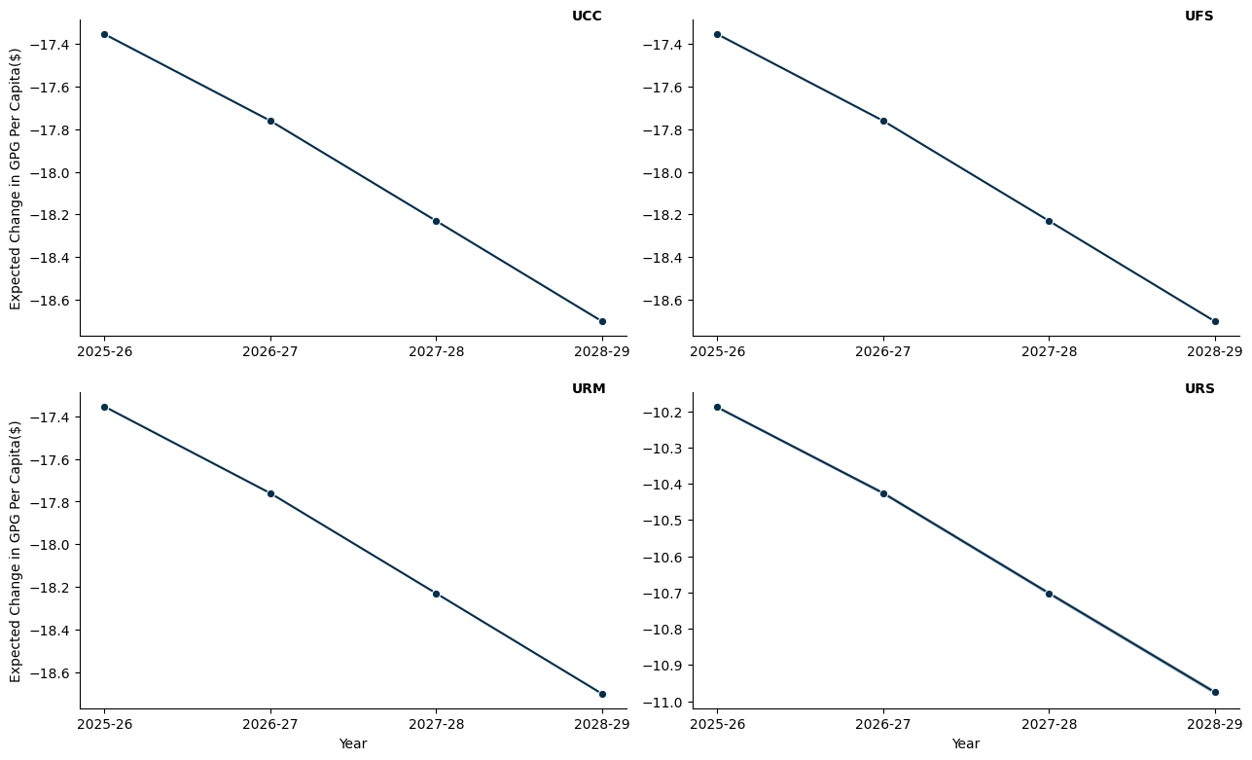

# 15. A World With No Per Capita Minimum Grant

* The model here applies a hypothetical per capita minimum grant constraint, set at 0%, to ensure that each jurisdiction receives at least this proportion of the funds if they were allocated on a per capita basis.
* The per capita minimum for the benchmark scenario is set to 30%, as is the status quo.

## 15.1 New South Wales

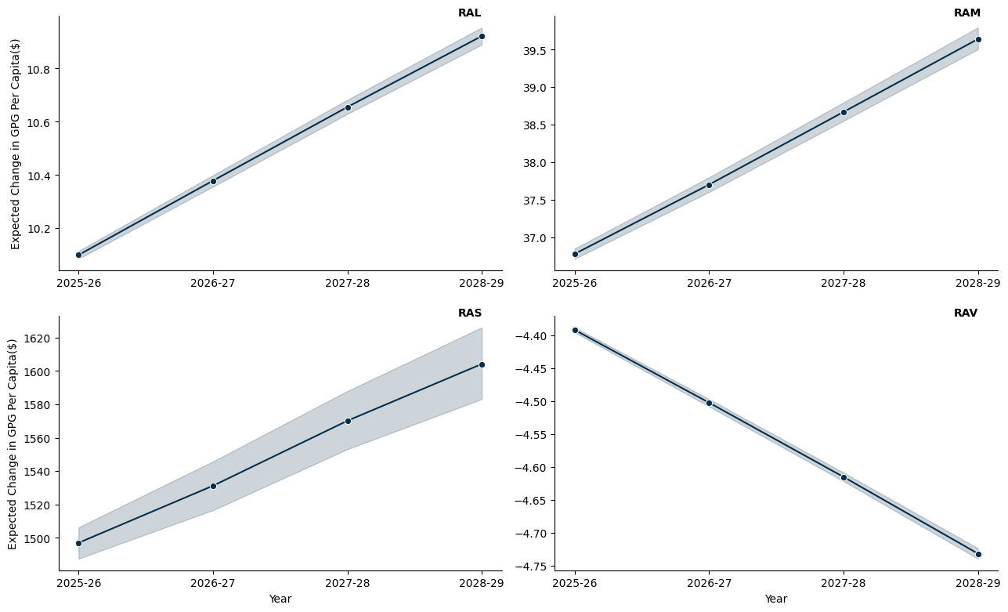

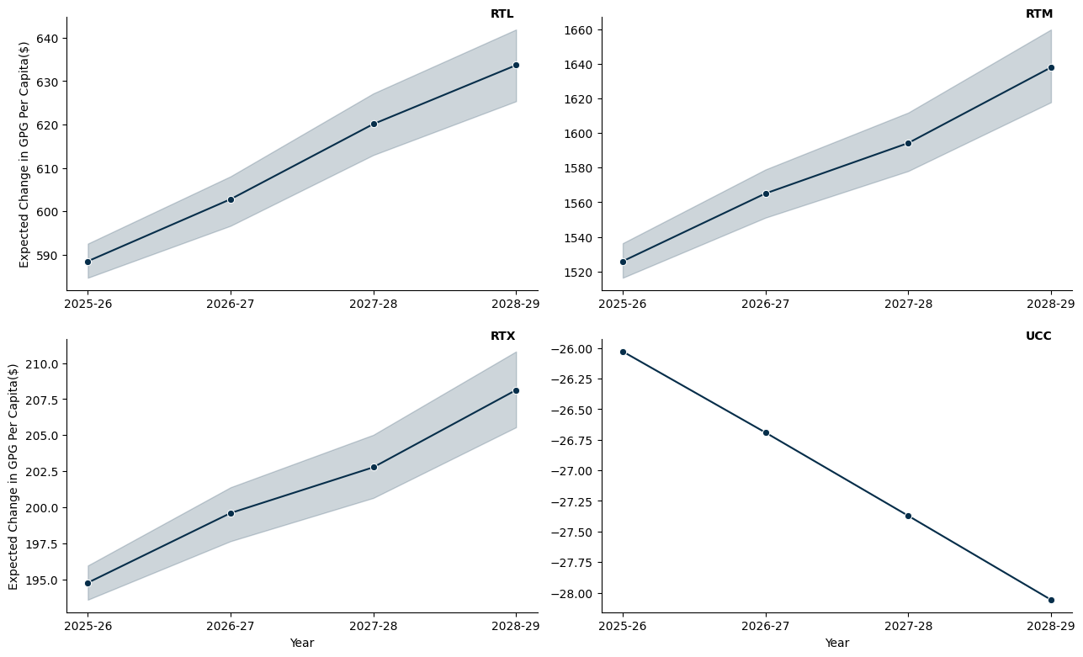

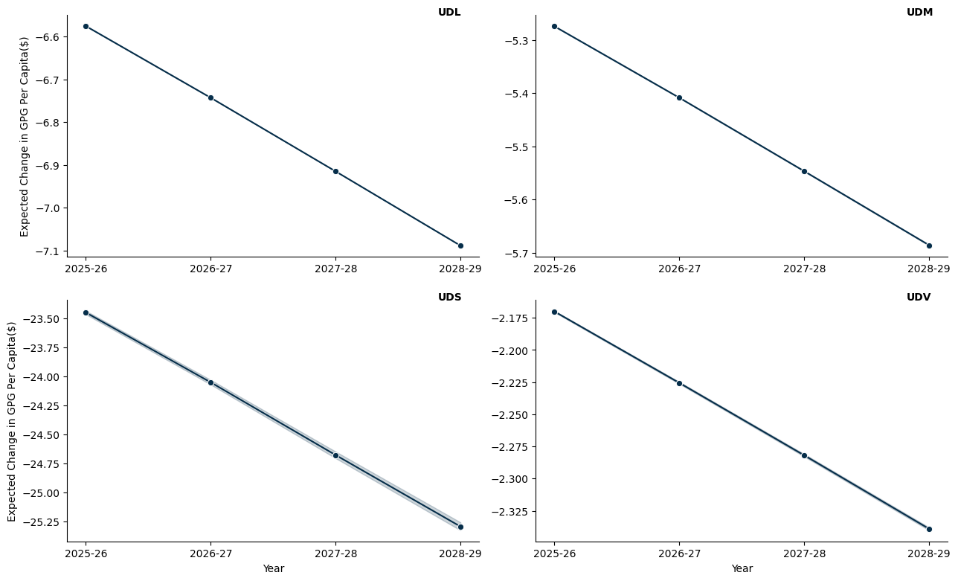

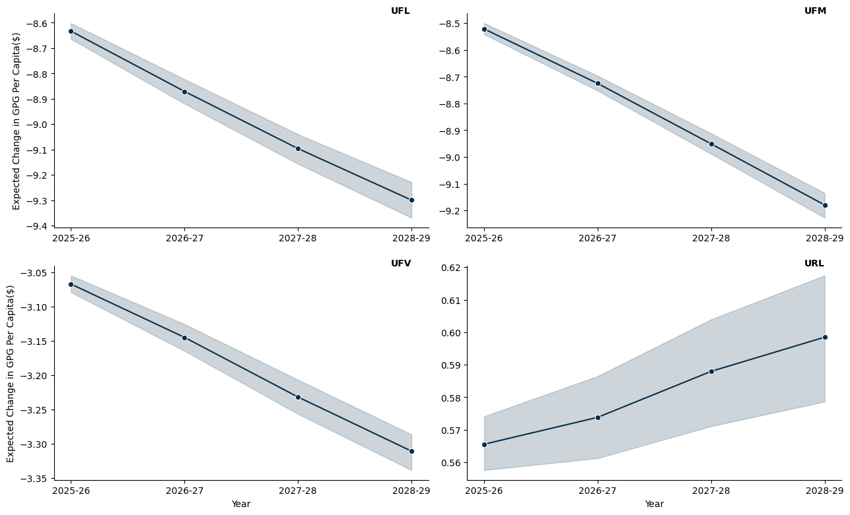

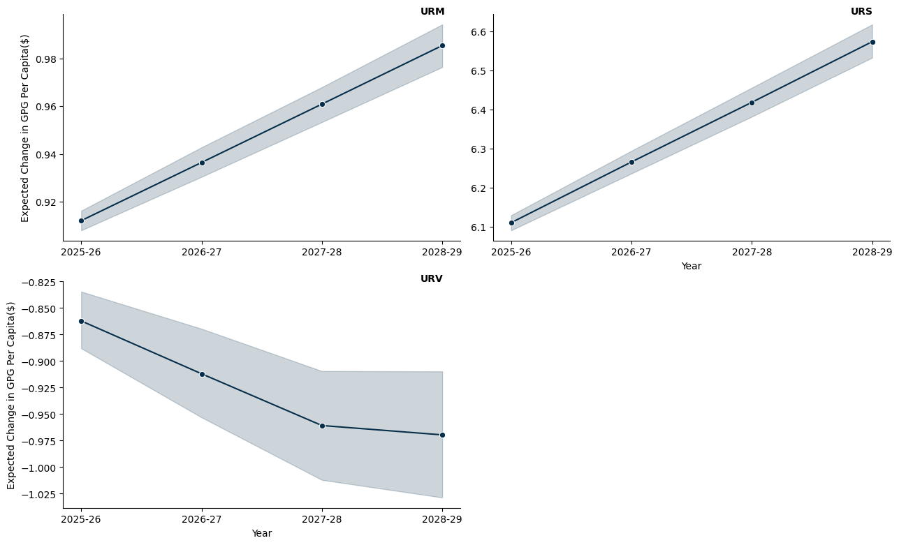

## 15.2 Victoria

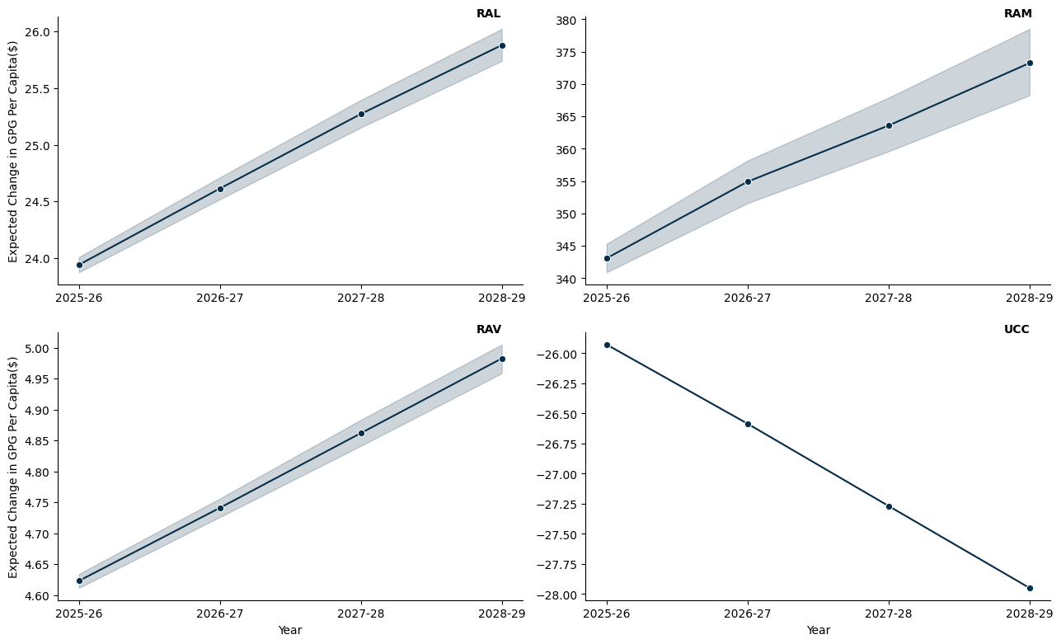

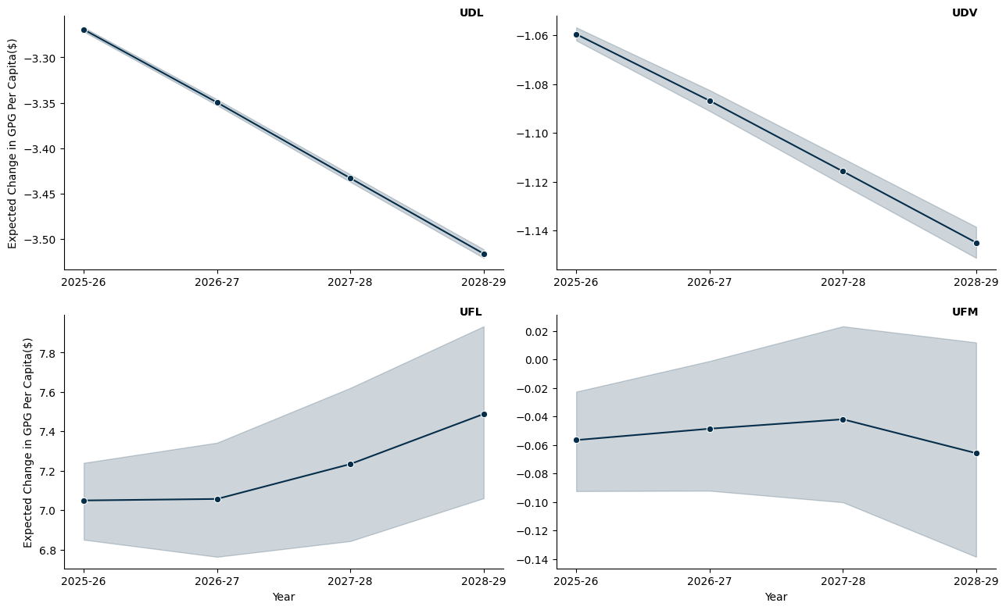

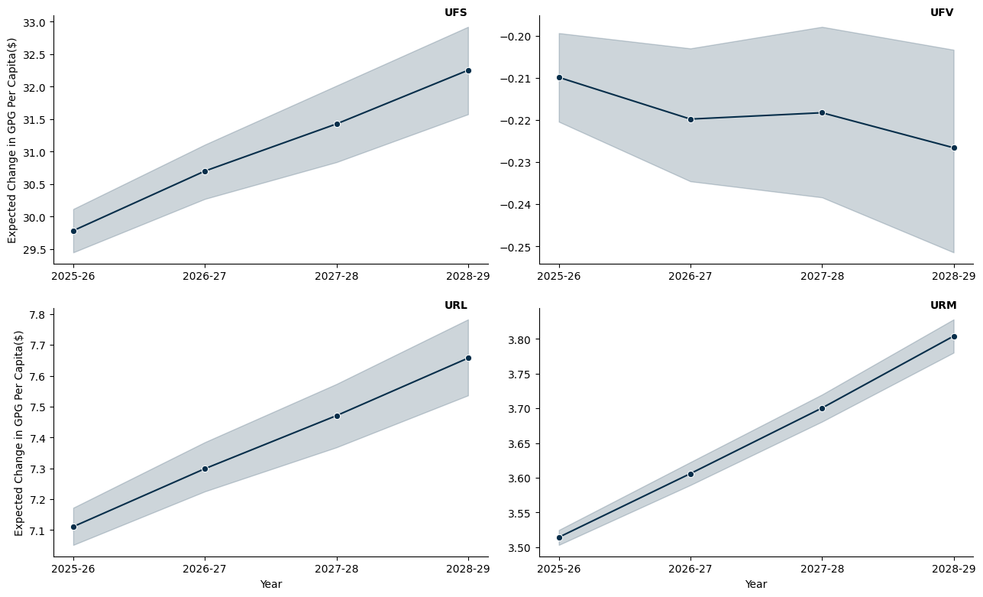

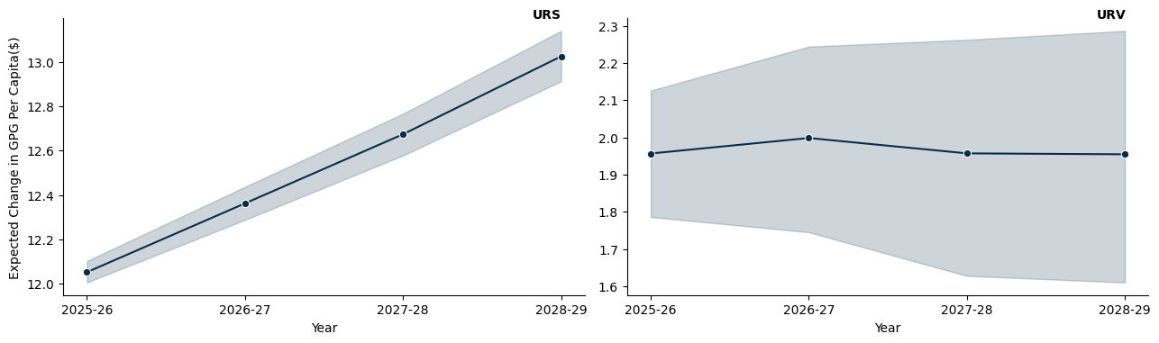

## 15.3 Queensland

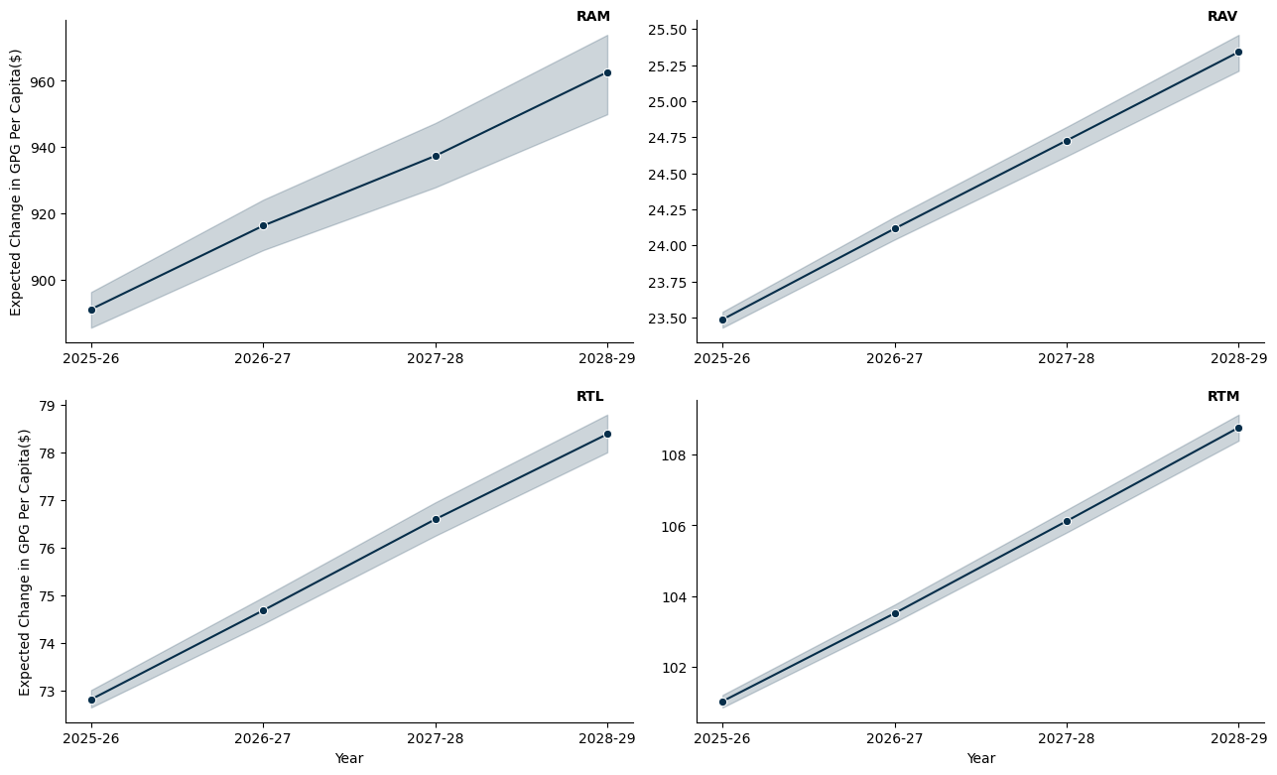

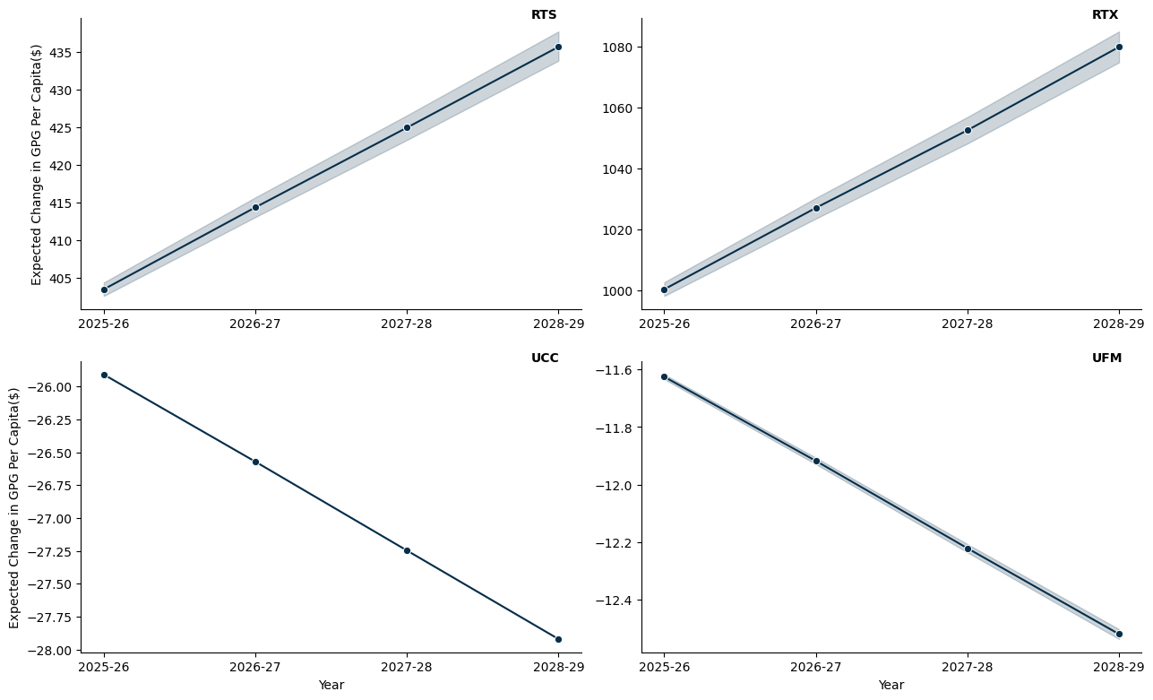

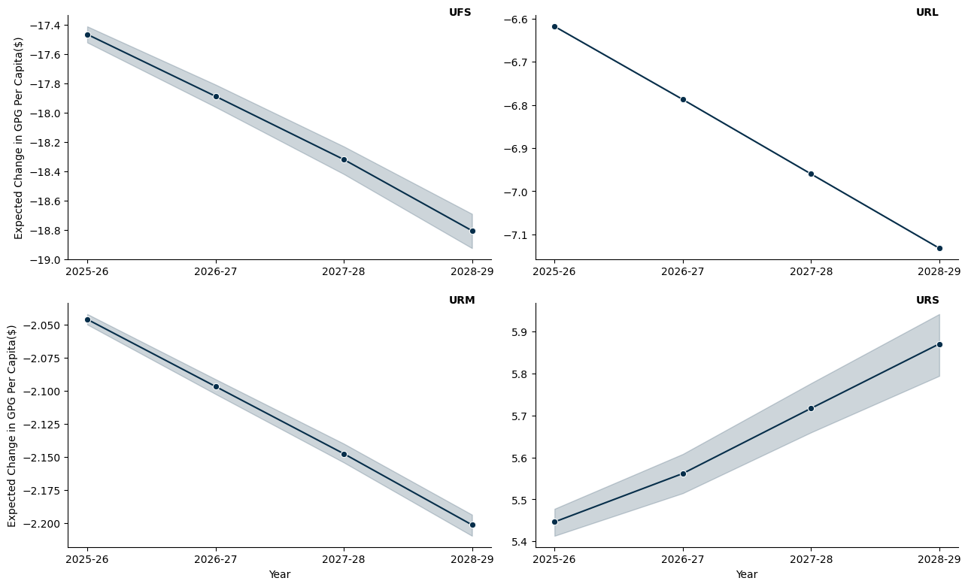

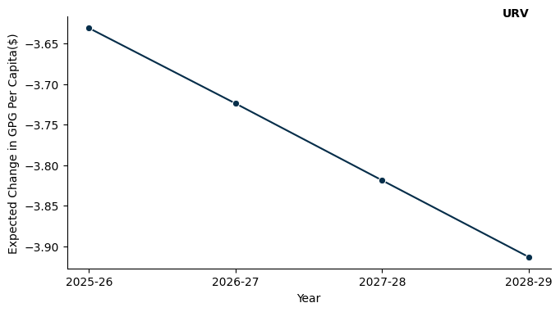

## 15.4 South Austrlalia

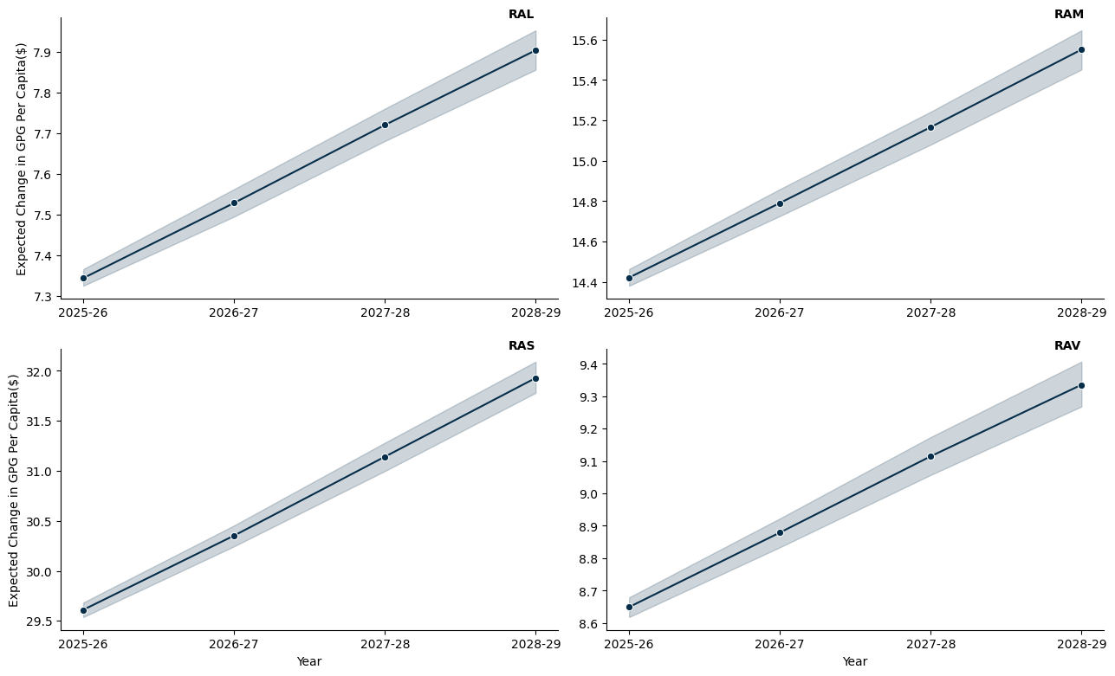

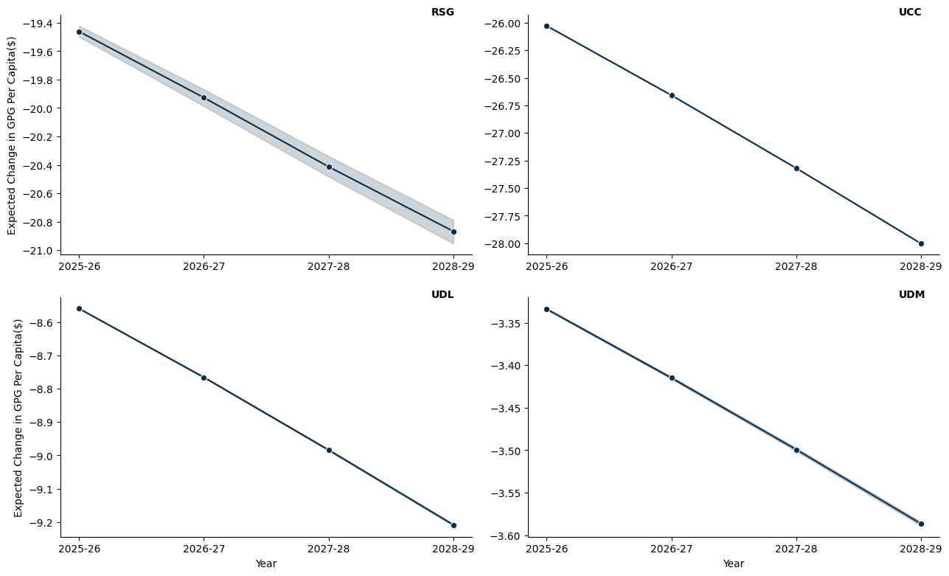

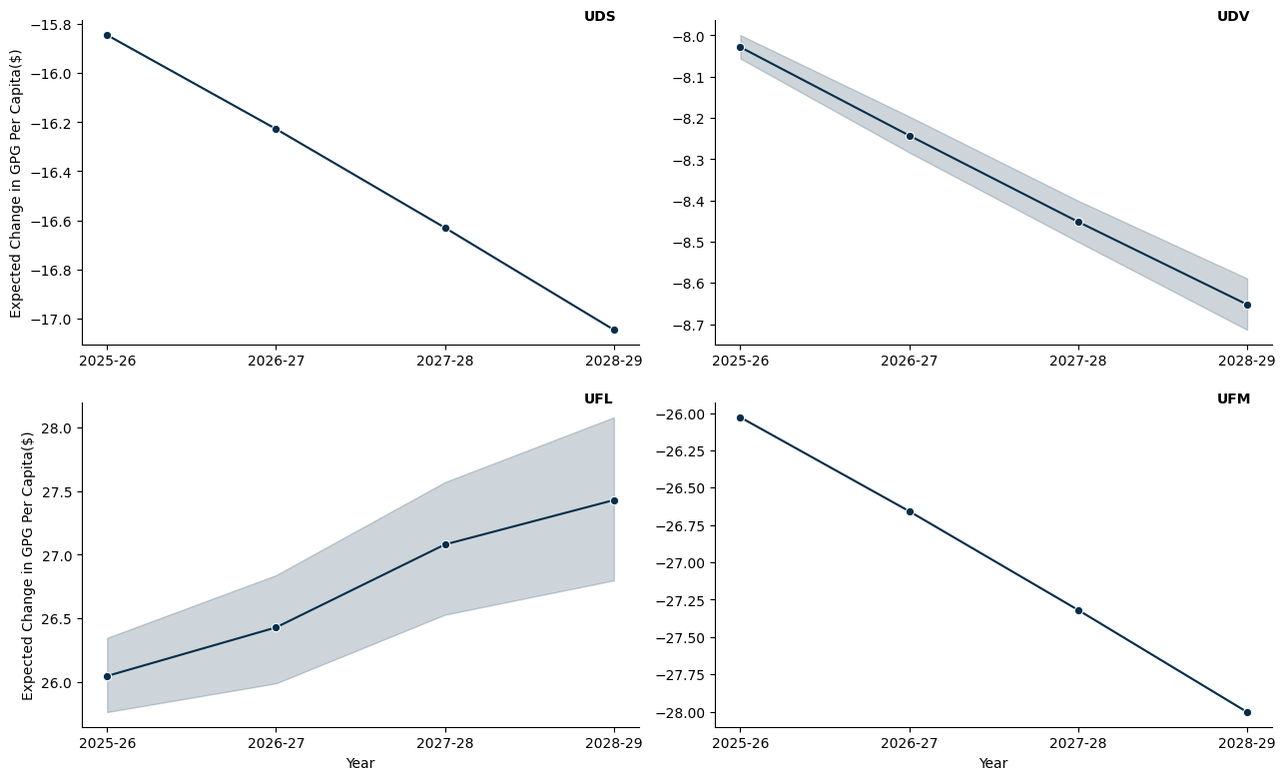

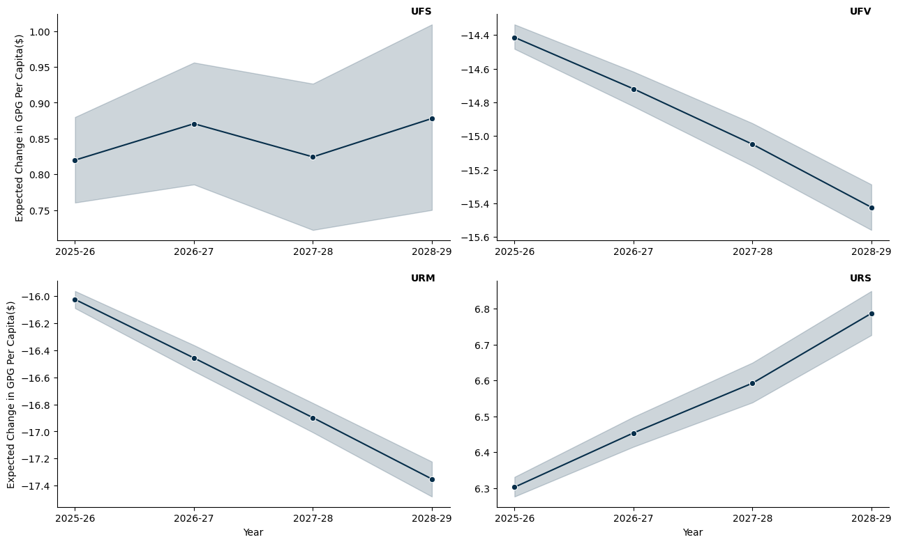

## 15.5 Western Australia

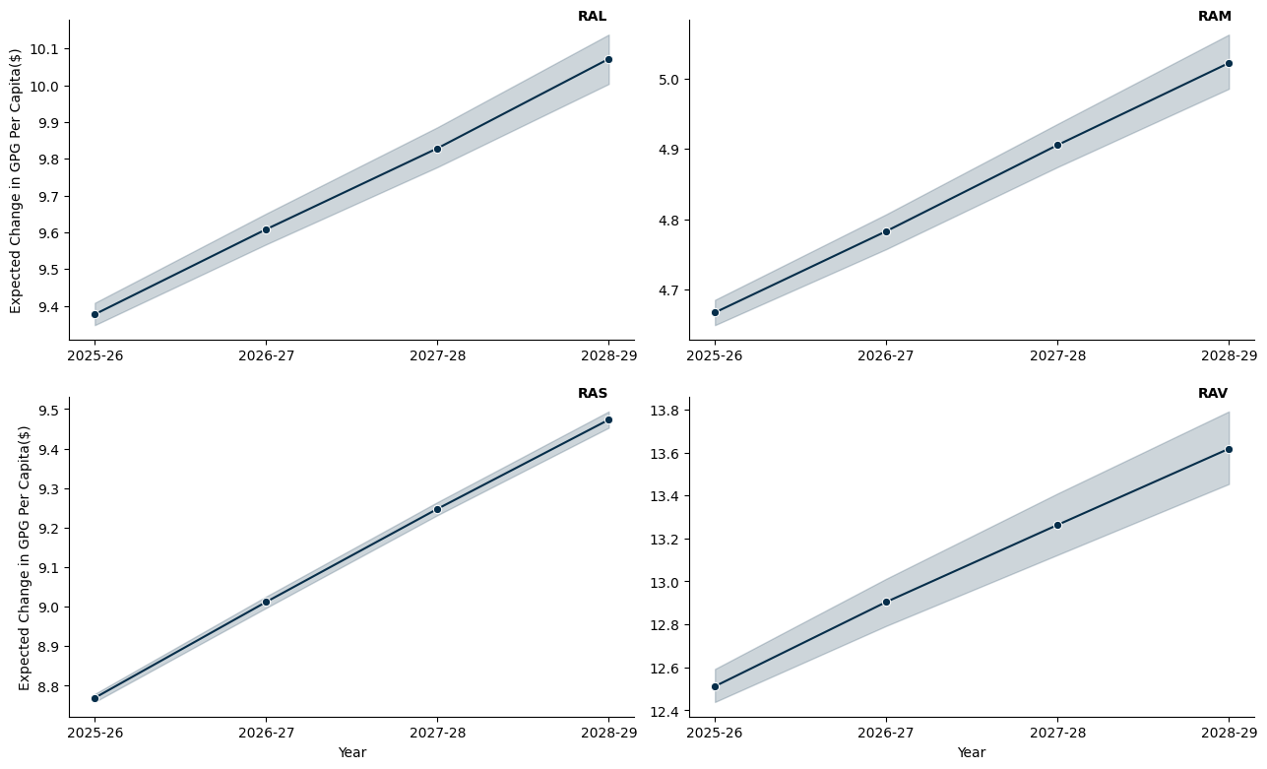

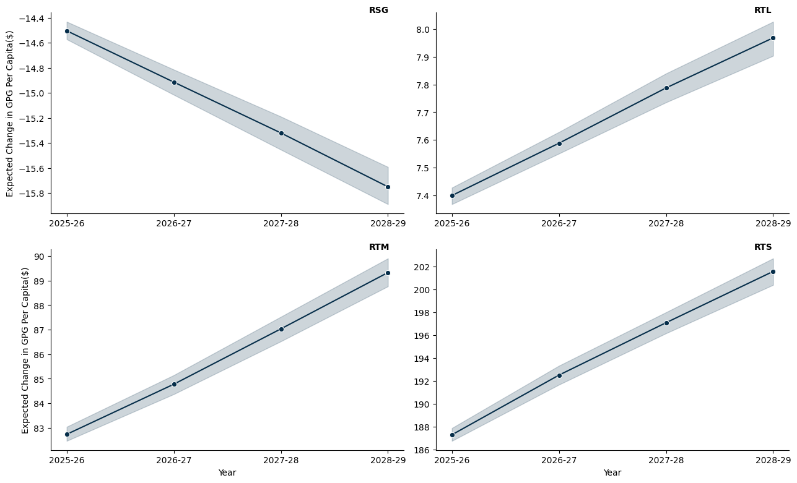

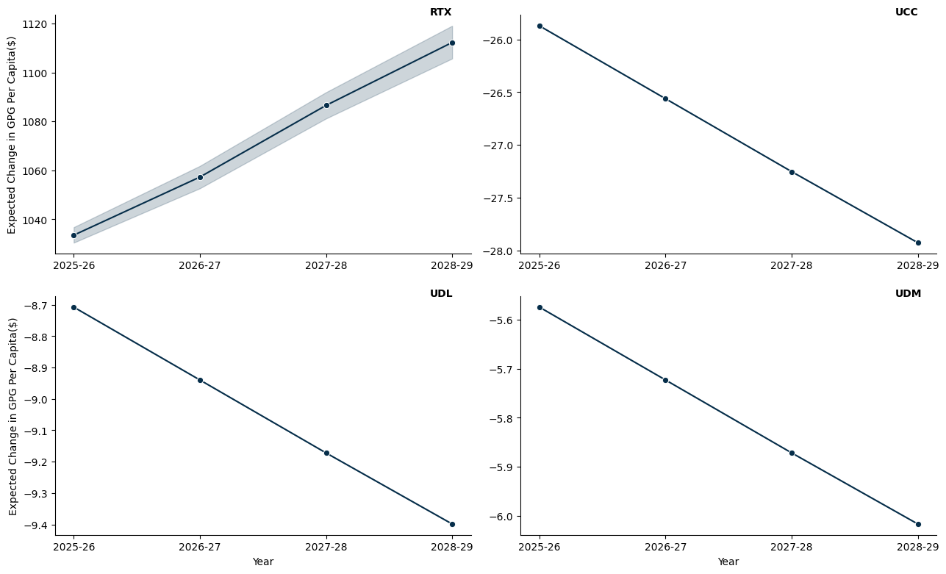

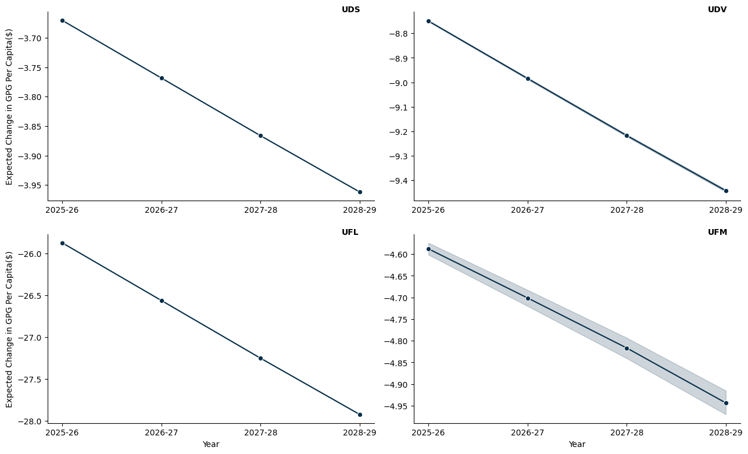

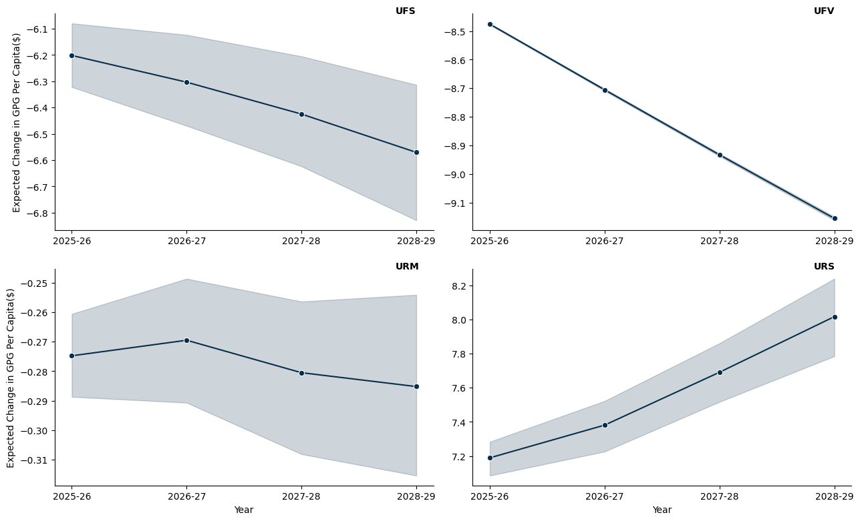

## 15.6 Tasmania

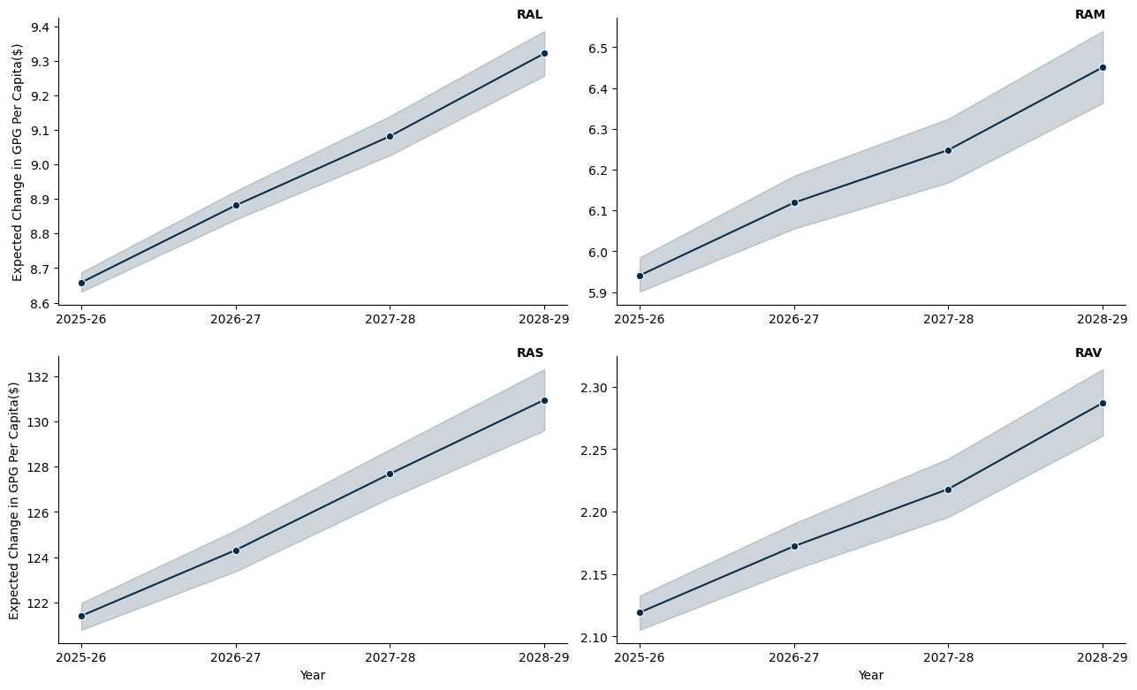

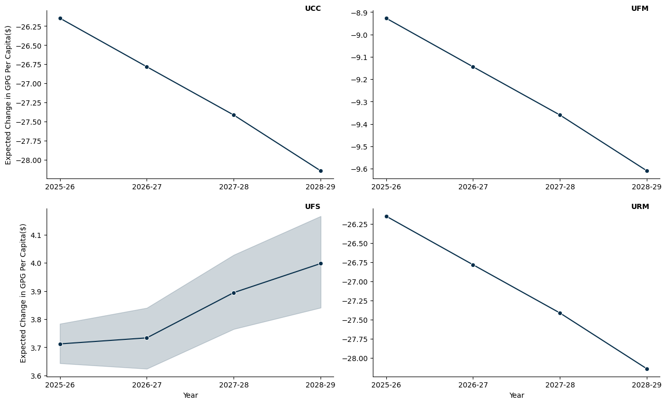

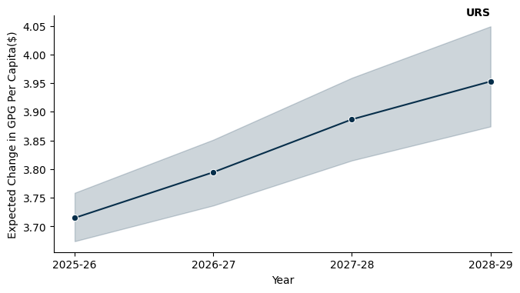

## 15.7 Northern Territory

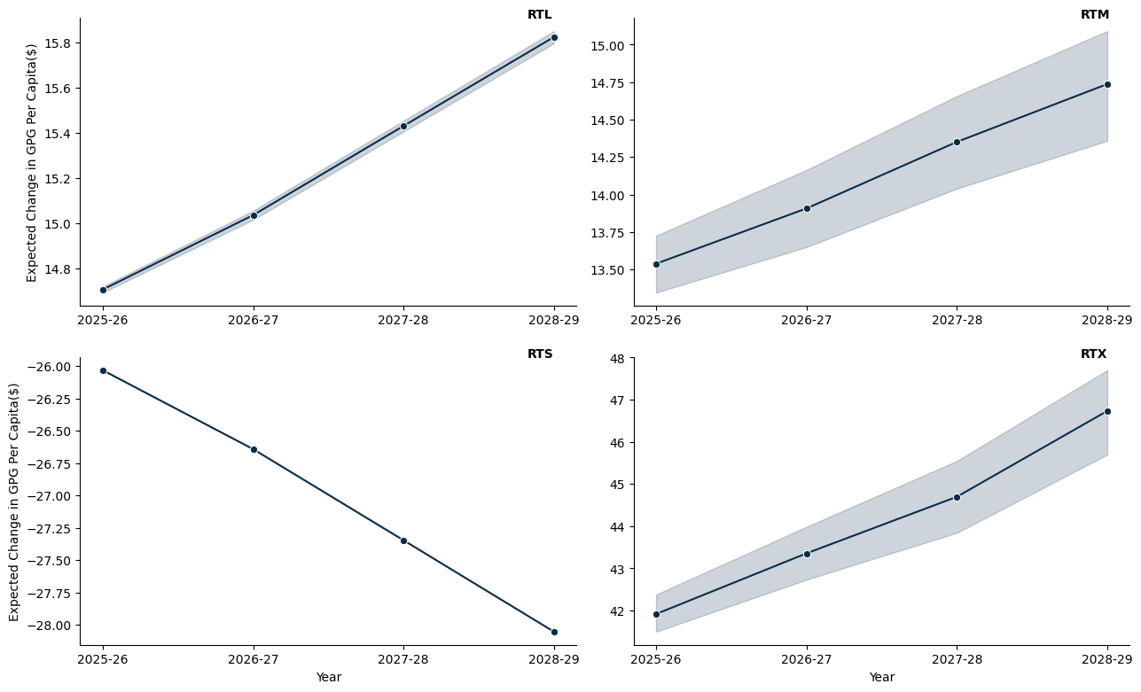

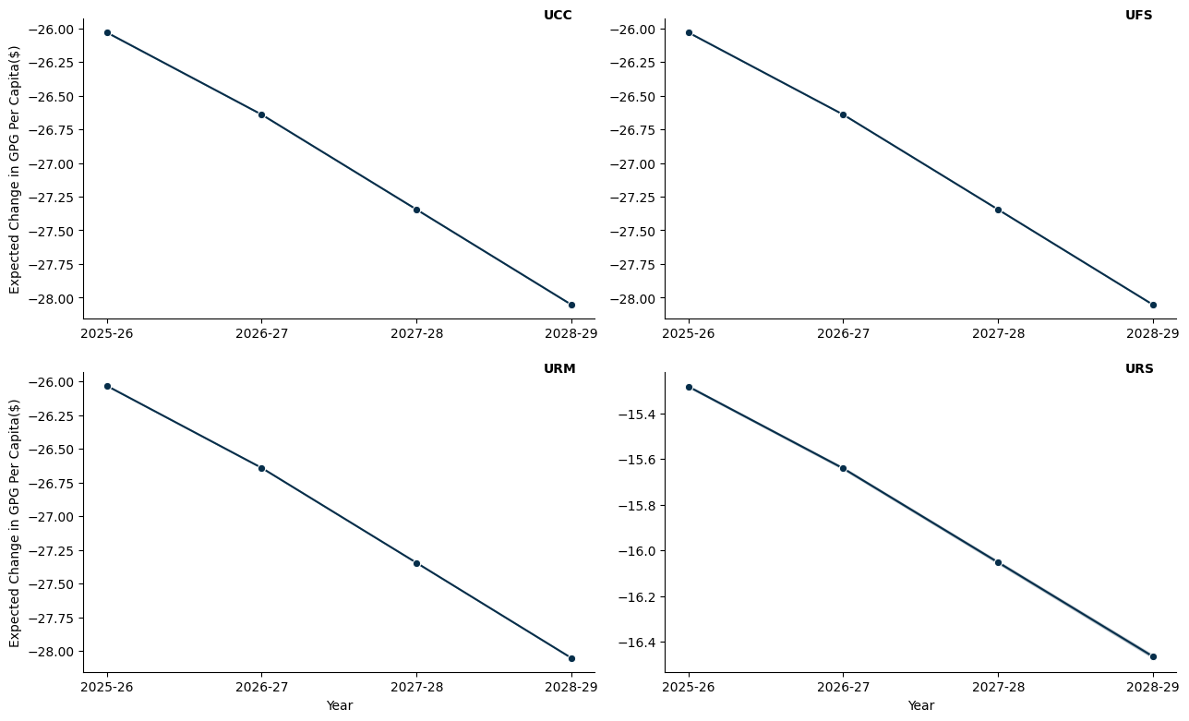

# References

Knuth DE (1984) ‘Literate programming’, *Comput. J.*, 27(2):97–111, doi:[10.1093/comjnl/27.2.97](https://doi.org/10.1093/comjnl/27.2.97).